Sunday
Jan. 18, 2015
p r a y . e v a n g e l i z e . d i s c i p l e.

Your Dream for 2015

Bible Text
Daniel chapter 2
Key Verse
Daniel 2:44
Key Word Kingdom-realm, reign

1. The dream is forgotten.
2. The dream is revealed.
3. The dream is decoded.
4. The dream is accepted.

Come and Worship with us on Wednesday
On Jan. 21, 2015
Prayer at 6pm, Worship/Bible study & Youth Group at 7pm
We'll study the Book of Galatians written by Apostle Paul around 49 AD. It is the first epistle written by Apostle Paul and is presenting the believers' freedom in Christ.
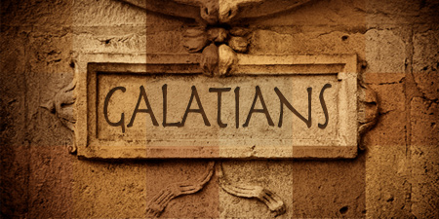 Do you know the Galatians' chapters?
1. Chapter 1-Christ's gospel
2. Chapter 2-Christ's defense
3. Chapter 3-Christ's promise
4. Chapter 4-Christ's church
5. Chapter 5-Christ's liberty
6. Chapter 6-Christ's cross.
Thursday- Come and join us for Downtown Evangelism at 7pm
at the Sonny Bono Statue.
Friday - Fasting day for our church (morning to noon or sundown).
Saturday - Prayer meeting at 11am, Church Cleaning at 12am.
Sunday - Prayer at 9am, Worship Service at 10am.

Discipleship: Colossians 3:16:"Let the word of Christ dwell in you richly in all wisdom, teaching and admonishing one another in psalms and hymns and spiritual songs, singing with grace in your hearts to the Lord. ¹⁷ And whatever you do in word or deed, do all in the name of the Lord Jesus, giving thanks to God the Father through Him." Let's read and memorize God's Word in the New Year. Colossians 3:16 is a good verse to start in the New Year.

Bible Promises: Romans 8:12-15 “Therefore, brethren, we are debtors, not to the flesh, to live after the flesh. For if ye live after the flesh, ye shall die: but if ye through the Spirit do mortify the deeds of the body, ye shall live. For as many as are led by the Spirit of God, they are the sons of God. For ye have not received the spirit of bondage again to fear; but ye have received the Spirit of adoption, whereby we cry, Abba, Father."

Water Baptism: Did you Know?
A. Paul was baptized after 3 days.
B. Jesus was baptized-Luke 3:21.
C. It is a symbol of Jesus' death and resurrection-Rom. 6:4-6.
D. The Philippi jailor was baptized at 2 AM in the morning.
E. The eunuch of Acts 8 was baptized immediately.

Pray for:
A. The Youth Ministry of our church.
B. Downtown Evangelism Ministry on Thursday at 7 PM.
C. Feeding the Poor Ministry on Friday 4:30 PM.
D. Prayer Ministry on SUN at 9 AM and WED at 6 PM.
E. The Nursing Home Ministry.
If you have any questions feel free to contact Pastor George or Lucia.
5000 Calle San Raphael #c5
Palm Springs, CA 92264
(760) 898-5848
Find us on Facebook

