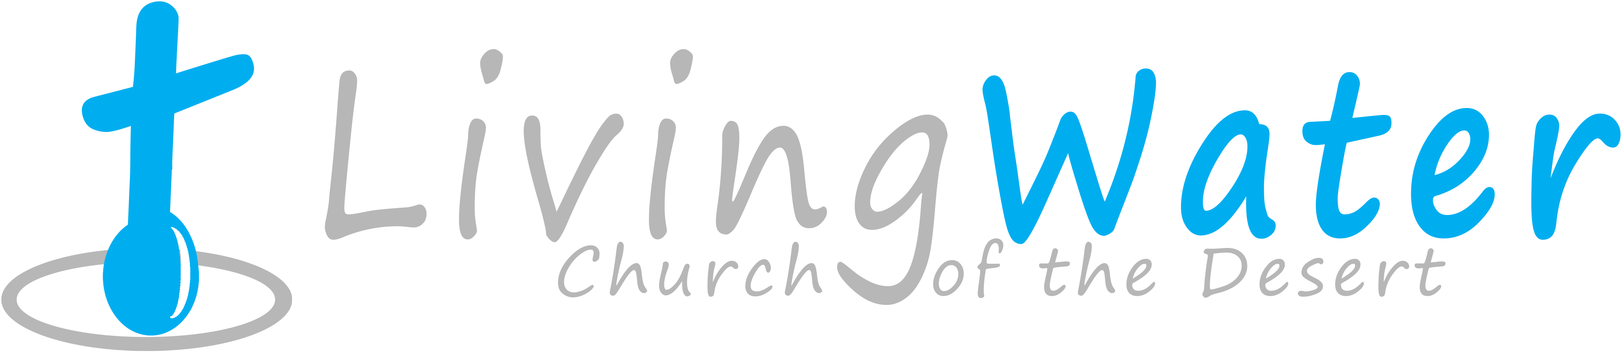 Sunday
Feb 1, 2015
p r a y . e v a n g e l i z e . d i s c i p l e.

The King's Training

Bible Text
Daniel chapter 4

Key Verse
Daniel 4:36

Key Word Restore –
Re-establish

1. Nebuchadnezzar’s dream.

2. Nebuchadnezzar’s stump.

3. Nebuchadnezzar’s pride.

4. Nebuchadnezzar’s change.

Come and Worship with us on Wednesday
On Feb 4th, 2015
Prayer at 6pm, Worship/Bible study & Youth Group at 7pm.
We'll study the Book of Galatians written by Apostle Paul around 49 AD. It is the first epistle written by Apostle Paul and is presenting the believers' freedom in Christ.
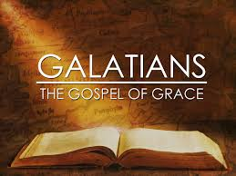 Do you know the Galatians' key words?
1. Chapter 1-Key Word-"gospel"
2. Chapter 2-Key Word-"justified"
3. Chapter 3-Key Word-"the law"
4. Chapter 4-Key Word-"redeem"
5. Chapter 5-Key Word-"the fruit"
6. Chapter 6-Key Word-"new life."

Thursday- Come and join us for Downtown Evangelism at 7pm
at the Sonny Bono Statue.
Friday - Fasting day for our church (morning to noon or sundown).
Saturday - Listen to a message on the radio on 92 FM at 10:05 AM,
Prayer meeting at 11am, Church Cleaning at 12am.
Sunday - Prayer at 9am, Worship Service at 10am.

Discipleship: ¹² As many as desire to make a good showing in the flesh, these would compel you to be circumcised, only that they may not suffer persecution for the cross of Christ. ¹³ For not even those who are circumcised keep the law, but they desire to have you circumcised that they may boast in your flesh. ¹⁴ But God forbid that I should boast except in the cross of our Lord Jesus Christ, by whom the world has been crucified to me, and I to the world. ¹⁵ What do we boast? Paul boasted in the Cross of Jesus Christ. Let's do the same as disciples of the Lord.

Women Bible Study: You are invited for the Women Bible Study on the first Saturday of each month at noon. Hope to see the ladies on Feb. 7th, 2015.

Bible Promises: Daniel 4:26-27
²⁶ "And inasmuch as they gave the command to leave the stump and roots of the tree, your kingdom shall be assured to you, after you come to know that Heaven rules. ²⁷ Therefore, O king, let my advice be acceptable to you; break off your sins by being righteous, and your iniquities by showing mercy to the poor. Perhaps there may be a lengthening of your prosperity."

Water Baptism: Did you Know?
a. Paul was baptized after 3 days.
b. Jesus was baptized-Luke 3:21.
c. It is a symbol of Jesus' death and resurrection-Rom. 6:4-6.
d. The Philippi jailor was baptized at 2 AM in the morning.
e. The eunuch of Acts 8 was baptized immediately.

You Are invited: Thursday at 7 PM to be a part of The University of Street Fair. We meet at 7 PM in front of Ruby's Restaurant, in downtown Palm Springs.

Feeding the Poor: We still continue to feed the poor. If you would like to donate food, you can do it on Wednesday from 6-8PM and on Sunday for 9-11:30 AM. The Church has a food pantry after Wednesday Worship Service for those families that are in need. Any food donations are really appreciated. Remember Proverbs 10:3," The Lord will not allow the righteous to hunger…"

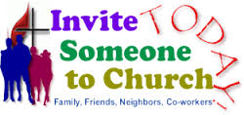
If you have any questions feel free to contact Pastor George or Lucia.
5000 Calle San Raphael #c5
Palm Springs, CA 92264
(760) 898-5848
Find us on Facebook

