Sunday
April 5th, 2014

p r a y. e v a n g e l i z e. d i s c i p l e.

He Is Risen!
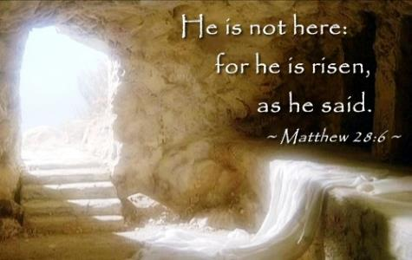

Bible Text
Luke 24:1-12
John 20:14-17
Key Verse
Luke 24:7
Key Word rise - ascend

1. The women at the empty tomb. Luke 24:1-3
2. The angels at the empty tomb. Luke 24:4-7
3. The worker at the empty tomb. Luke 24:8-12
4. The Master at the empty tomb. John 20:11-17

Come and Worship with us on Wednesday
On April 8th, 2015
You are invited to worship with us on Wednesday at 7 PM.
Expect an answer from the Lord.
Thursday- Come and join us for Downtown Evangelism at 7pm
at the Sonny Bono Statue.
Friday - Fasting day for our church, (Morning to noon or sundown).
Saturday - Prayer meeting at 11am, Church Cleaning at 12am.
Sunday - Prayer at 9am, Worship Service at 10am.

Invite a friend to church

Discipleship: Mat. 4:19-20" Then He said to them, "Follow Me, and I will make you fishers of men." ²⁰ They immediately left their nets and followed Him.
Peter and Andrew obeyed and followed Jesus immediately. There was no delay and no murmuring. Jesus' disciple will become a fisher of men. Are you a fisher of men?

Promises: Mark 11:22-26, ²² So Jesus answered and said to them, "Have faith in God. ²³ For assuredly, I say to you, whoever says to this mountain, 'Be removed and be cast into the sea,' and does not doubt in his heart, but believes that those things he says will be done, he will have whatever he says. ²⁴ Therefore I say to you, whatever things you ask when you pray, believe that you receive them, and you will have them. ²⁵ "And whenever you stand praying, if you have anything against anyone, forgive him, that your Father in heaven may also forgive you your trespasses. ²⁶ But if you do not forgive, neither will your Father in heaven forgive your trespasses."

Downtown Evangelism: Every Thursday at 7 PM we meet in front of Sony Bono statue in downtown to represent Jesus and the work He gave us to do, Mark 16:15, "Go into all the world and preach the gospel to every creature.” Please, fill out the connection card if you would like to be a part of evangelism team.

If you have any questions feel free to contact Pastor George or Lucia.
5000 Calle San Raphael #c5
Palm Springs, CA 92264
(760) 898-5848Find us on Facebook
Invite a friend to church

