p r a y . e v a n g e l i z e . d i s c i p l e.
Sept. 4, 2016
Message: Paul, the Revival Man
The Book of Philippians, chapter 1:1-18

OUTLINE:
I. Apostle Paul, the servant of Christ.
II. Apostle Paul, the soldier of Christ.
III. Apostle Paul, the witness of Christ.
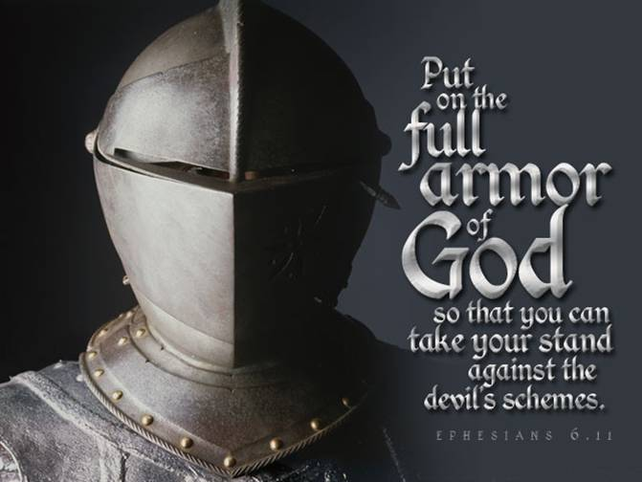

YOU ARE INVITED!
WEDNESDAY at 7 PM: The Book of Romans
You are invited to study the Book of Romans which contains the Constitution of the Christian faith and the Bill of Rights of the Christian faith. This book is the only one in the Bible that presents in a spiritual and logical order the Gospel of Jesus Christ! We pray and ask the Lord to bring a revival in our church as we study this book.

SCHEDULE FOR THIS WEEK

Wednesday 6 pm- Prayer Service.
Sept. 7 7 pm- Worship Service and study of the Book of Romans
8 pm- Fellowship on every Wednesday.

Thursday 7 pm- Street Fair University in Downtown in front
Sept. 8 of the Sonny Bono Statue.

Saturday Please, pray at your home for the Sunday Service.
Sept. 10

Sunday 9 am- Prayer Service.
Sept. 11 10am- Worship Service.
10am- Children Ministry from 10am until 11:10 am.
Fellowship after every service.
10:30am- Youth Ministry until 11:30 am.

10 Reasons to be a Disciple
1. It is a Bible’s command to all believers! Mat. 28:19
2. Jesus made 12 disciples plus 70 in 3 ½ years.
3. Jesus was baptized and the disciple is baptized. Luke 3:21
4. It is an act of obedience to Jesus’ command. Mat 28:19.
5. The disciple is an obedient follower of Jesus Christ.
6. The disciple is studying God’s Word daily-Col. 3:16
7. The disciple is praying day and night-Luke 18.
8. The word “disciple” is used 300 times in the N.T.
9. It is an act of commitment to the Great Commission.
10.The disciple is multiplying himself day and night.
Fill out the connection card today to enroll in the disciple class.
Street Fair University: If you would like to be a part of the evangelistic team on Thursday evening (7PM), please let us know. Please, fill out the connection. card.

If you have any questions feel free to contact Pastor George or Lucia
Living Water Church
5000 Calle San Raphael #c5 info@livingwaterps.org
Palm Springs, CA 92264 (760) 898-5848

