p r a y . e v a n g e l i z e . d i s c i p l e.
Sept. 11, 2016
Message: 5 Reasons for Paul’s Success
Philippians 1:15-30

OUTLINE: 5 Reasons for Paul’s Success
I. Apostle Paul was ready to pray.
II. Apostle Paul was ready to preach
III. Apostle Paul was ready to labor.
IV. Apostle Paul was ready to rejoice
V. Apostle Paul was ready to suffer.

WEDNESDAY at 7 PM: The Book of Romans
You are invited to study the Book of Romans.

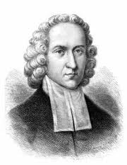
The Great Awakening
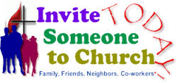
It was 1734 and immorality, debauchery and Low Church attendance made Jonathan Edwards kneel on Sunday morning and pray. Then he named in the poppet the sins; neglect of family prayer, disregard for the Lord’s Day, greediness, sensuality, etc. In December the revival began and spilled over to one hundred communities. The revival continued for twenty years and between twenty thousand and fifty thousand people became believers, which is equivalent to twenty five million in today’s population. It developed the Christian principles found in the foundation of the American government.

SCHEDULE FOR THIS WEEK

Wednesday 6 pm- Prayer Service.
Sept 13 7 pm- Worship Service and study of the Book of Romans
8 pm- Fellowship on every Wednesday.

Thursday 7 pm- Street Fair University in Downtown in front
Sept. 14 of the Sonny Bono Statue.

Saturday Please, pray at your home for the Sunday Service.
Sept. 16

Sunday 9 am- Prayer Service.
Sept. 17 10am- Worship Service.
10am- Children Ministry from 10am until 11:10 am.
Fellowship after every service.
10:30am- Youth Ministry until 11:30 am.

The Disciples’ Work
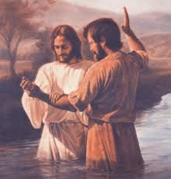
1. Labor for the spiritual food.
2. Know God and His Son-John 17:3
3. Enter the narrow gate-Mt 7:14
4. Forsake all for Jesus-Mt.19:27
5. Live a life free of sin-Romans 5:21
6. Sow in the Holy Spirit-Gal. 6:8
7. Endure temptation-James 1:12
8. Overcome sin in your life-Revelation
9. Be faithful unto death-Rev. 2:10
10. Let the Word dwell in you-Col. 3:16
11. Fight the good fight of faith-2 Tim. 4:7
12. Bear the fruit of the Spirit-John 15
13. Be filled with the Holy Spirit
Fill out the connection card today to enroll in the disciple class.
Street Fair University: If you would like to be a part of the evangelistic team on Thursday evening (7PM), please let us know. Please, fill out the connection.
If you have any questions feel free to contact Pastor George or Lucia
Living Water Church
5000 Calle San Raphael #c5 info@livingwaterps.org
Palm Springs, CA 92264 (760) 898-5848

