p r a y . e v a n g e l i z e . d i s c i p l e.



Sept. 25, 2016

Message: Shinning Like the Stars

Philippians 2:12-30

OUTLINE: Shinning Like the Stars

**Philippians # 2:12-30**

Outline

1. The humility and example of the believers.

2. The humility and example of Apostle Paul.

3. The humility and example of Timotheous.

4. The humility and example of Epaphroditus.

WEDNESDAY at 7 PM: The Book of Romans

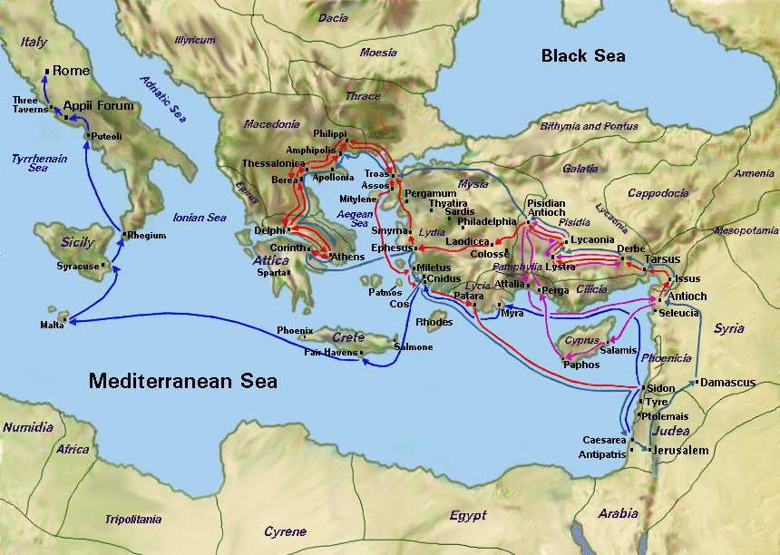

**Joy and sacrifice** connect together in verses Philippians 1:17 and 18. Sacrifice leads to gladness and joy and even more joy! Paul is jubilant," *Rejoice with me*!!" Don’t be terrified by your adversary. Sacrifice creates godly perfume that goes straight in the heavenly, in the presence of the Lord. Tertullian said," The blood of the martyrs is the seed of the church. We are forsaken by people and not by Almighty God, who gives us the VICTORY!" 2 Cor. 6:4-10.

SCHEDULE FOR THIS WEEK

Wednesday *6 pm-* Prayer Service.

Sept 28 *7 pm****-* Worship Service** and study of the Book of Romans

*8 pm-* Fellowship on every Wednesday.

Thursday *7 pm-* Street Fair University in Downtown in front

Sept. 29 of the Sonny Bono Statue.

Saturday Please, pray for the Sunday Service using Bible verses.

Sept. 30

Sunday *9 am*- Prayer Service.

Oct. 2 *10am*- Worship Service.

*10am*- **Children Ministry** from 10am until 11:10 am.

Fellowship after every service.

*10:30am*- Youth Ministry until 11:30 am.

Revelation # 1, The Resurrected Christ

Jesus Christ, the faithful witness, the firstborn from the dead, and the ruler over the kings of the earth. To Him who loved us and washed us from our sins in His own blood, **6** and has made us kings and priests to His God and Father, to Him *be* glory and dominion forever and ever. Amen. **7** Behold, He is coming with clouds, and every eye will see Him, even they who pierced Him. And all the tribes of the earth will mourn because of Him. Even so, Amen. **8** “I am the Alpha and the Omega, *the* Beginning and *the* End,” says the Lord, “who is and who was and who is to come, the Almighty Rev 1:5-8 (NKJV)

**SERVANTHOOD-**Let us know if you would like to help in the church with the cleaning, ushering, prayer for the Sunday service or Wednesday service, evangelism, parking lot on Sunday’s morning for 25 minutes or setting the table with refreshments on Wednesday or Sunday. Fill out the connection card today

**Fill out the connection card today to enroll in the disciple class.**

**Street Fair University:** If you would like to be a part of the evangelistic team on Thursday evening (7PM), please let us know. Please, fill out the connection.

If you have any questions feel free to contact Pastor George or Lucia

Living Water Church

5000 Calle San Raphael #c5 info@livingwaterps.org

Palm Springs, CA 92264 (760) 898-5848