p r a y . e v a n g e l i z e . d i s c i p l e.
Oct. 9, 2016
Message: Paul Great Race
Philippians 3:12-21

OUTLINE: Paul’s Great Race
Philippians # 3:1-11

1. Paul wants to know Jesus Christ.
2. Paul wants to press for the prize.
3. Paul wants to fight as an example

WEDNESDAY at 7 PM: The Book of Romans

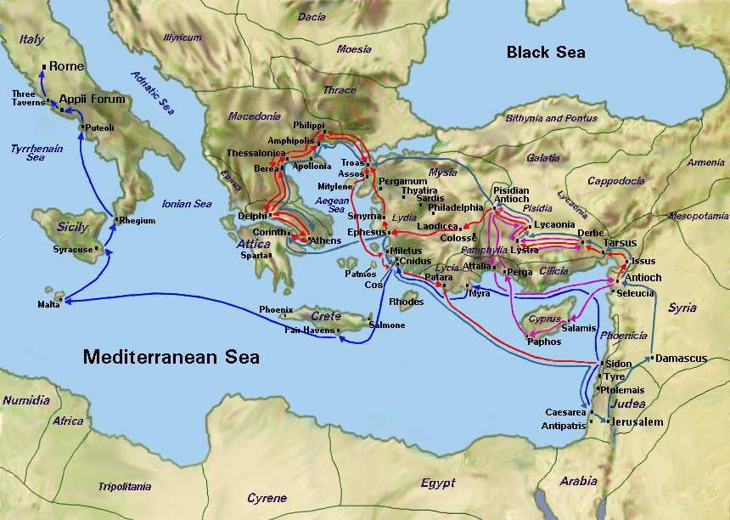
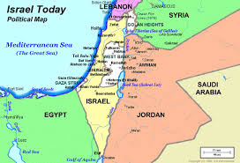

Jeremiah Lumpier's example
Six men came to pray many years ago and, as a result of an invitation given by Jeremiah Lumpier who was a merchant. His church was not doing well. Jeremiah used to pray in his own church after he had visited people and encouraged them to attend church. Suddenly an idea came to him. May be people will be willing to come to pray a short time at noon! And he put up a placard. The meeting had to start at 12 noon and nobody came until 12:30! Suddenly one man came, then another until there were six. They prayed a short time and decided to pray again next Wednesday. Lanphier did not know that this was the beginning of a revival that will led to Christ one million people!
SCHEDULE FOR THIS WEEK

Wednesday 6 pm- Prayer Service.
Oct. 12 7 pm- Worship Service and study of the Book of Romans
8 pm- Fellowship on every Wednesday.

Thursday 7 pm- Street Fair University in Downtown in front
Oct. 13 of the Sonny Bono Statue.

Saturday Please, pray for the Sunday Service using Bible verses.
Oct. 15

Sunday 9 am- Prayer Service.
Oct. 16 10am- Worship Service.
10am- Children Ministry from 10am until 11:10 am.
Fellowship after every service.
10:30am- Youth Ministry until 11:30 am.

Are You ready to be Baptized?
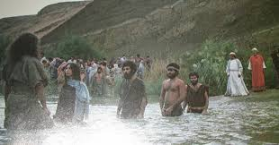
If you are born again, you are
Ready to be baptized!

Fill up the connection card
Today!

SERVANTHOOD-Let us know if you would like to help in the church with the cleaning, ushering, prayer for the Sunday service or Wednesday service, evangelism, parking lot on Sunday’s morning for 25 minutes or setting the table with refreshments on Wednesday or Sunday. Fill out the connection card today
Fill out the connection card today to enroll in the disciple class.
Street Fair University: If you would like to be a part of the evangelistic team on Thursday evening (7PM), please let us know. Please, fill out the connection.
If you have any questions feel free to contact Pastor George or Lucia
Living Water Church
5000 Calle San Raphael #c5 info@livingwaterps.org
Palm Springs, CA 92264 (760) 898-5848

