p r a y . e v a n g e l i z e . d i s c i p l e.
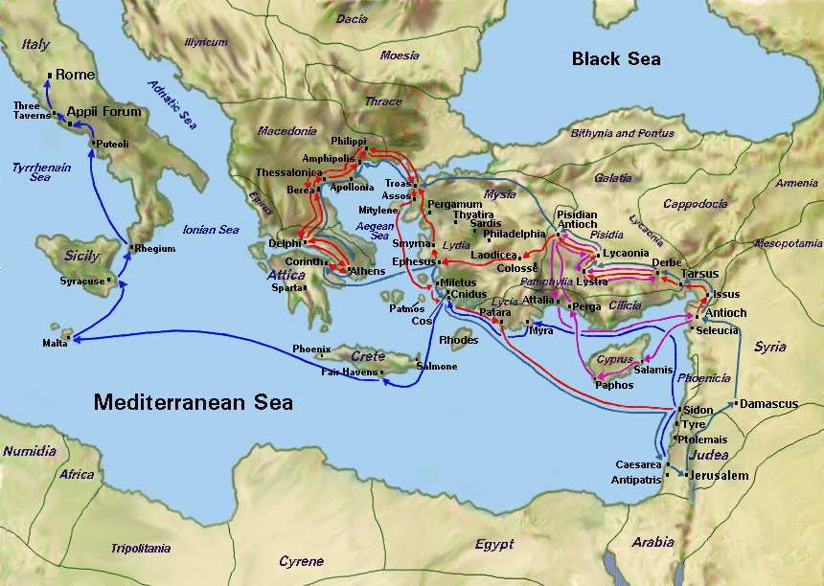
Oct. 23, 2016
Message: God’s providing Power
Philippians 4:9-20

OUTLINE:
1. The learning power of the church. v. 9-10
2. The gratitude power of the church v.10-14
3. The altruistic power of the church v.15-17
4. The financial power of the Lord. v.19-23.
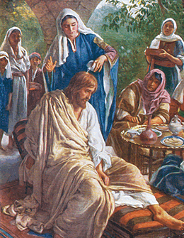

WEDNESDAY at 7 PM: The Book of Romans
12 Blessings of the SPIRIT in Romans
1. Make me free from sin……Romans 8:2
2. Cancels death penalty……. Romans 8:2
3. Fulfills righteousness ……..Romans 8:4
4. Indwells the believers……..Romans 8:9
5. Quicken the mortal body….Romans 8:11
6. Mortify the sinful members-Romans 8:13
7. Leads us as children of God-Romans 8:14
8. Adopt us in God's family….Romans 8:15
9. Bears witness for sonship…Romans 8:16
10. Gives life to our bodies…… Romans 8:10
11. Help us in our infirmities…. Romans 8:26
12. Makes intercession for us… Romans 8:26.

SCHEDULE FOR THIS WEEK

Wednesday 6 pm- Prayer Service.
Oct. 26 7 pm- Worship Service and study of the Book of Romans
8 pm- Fellowship on every Wednesday.

Thursday 7 pm- Street Fair University in Downtown in front
Oct. 27 of the Sonny Bono Statue.

Saturday Please, pray for the Sunday Service using Bible verses.
Oct. 29

Sunday 9 am- Prayer Service.
Oct. 30 10am-Worship Service.
10am- Children Ministry from 10am until 11:10 am.
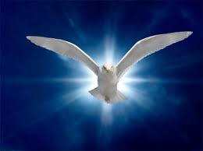
Fellowship after every service.
10:30am-Youth Ministry until 11:30 am.

Are You ready to be Baptized?
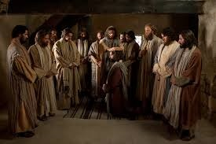
If you are born again, you are
Ready to be baptized!

Fill up the connection card
Today!

SERVANTHOOD-Let us know if you would like to help in the church with the cleaning, ushering, prayer for the Sunday service or Wednesday service, evangelism, parking lot on Sunday’s morning for 25 minutes or setting the table with refreshments on Wednesday or Sunday. Fill out the connection card today
Fill out the connection card today to enroll in the disciple class.
Street Fair University: If you would like to be a part of the evangelistic team on Thursday evening (7PM), please let us know. Please, fill out the connection card.
If you have any questions feel free to contact Pastor George or Lucia
Living Water Church
5000 Calle San Raphael #c5 info@livingwaterps.org
Palm Springs, CA 92264 (760) 898-5848

