p r a y . e v a n g e l i z e . d i s c i p l e.
Nov. 6, 2016
Message: Do Business Until I Come
Luke 19:11-27

OUTLINE:
1. The mission of Jesus' ten servants
2. The reward of Jesus' two servants
3. The excuses of Jesus' lazy servant.
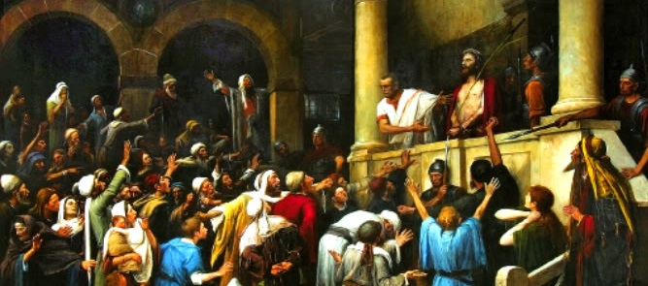

WEDNESDAY at 7 PM: The Book of Romans
You are invited to study the Book of Romans
Bible Promises:
³ But when you do a charitable deed, do not let your left hand know what your right hand is doing, ⁴ that your charitable deed may be in secret; and your Father who sees in secret will Himself reward you openly.Matt 6:2-4.
¹⁹ "Do not lay up for yourselves treasures on earth, where moth and rust destroy and where thieves break in and steal; ²⁰ but lay up for yourselves treasures in heaven, where neither moth nor rust destroys and where thieves do not break in and steal. Matt 6:19-20.

Thanksgiving Celebration Soon!
We will celebrate the thanksgiving soon, Please, donate food for this event as the Lord is leading you.
SCHEDULE FOR THIS WEEK

Wednesday 6 pm- Prayer Service.
Nov. 9 7 pm- Worship Service and study of the Book of Romans
8 pm- Fellowship on every Wednesday.

Thursday 7 pm- Street Fair University in Downtown in front
Nov. 10 of the Sonny Bono Statue.

Saturday Please, pray for the Sunday Service using Bible verses.
Nov. 12

Sunday 9 am- Prayer Service.
Nov. 13 10am-Worship Service.
10am- Children Ministry from 10am until 11:10 am.
Fellowship after every service.
10:30am-Youth Ministry until 11:30 am.

Are you ready to be baptized? Please fill out the connection card.

THANKSGIVING CELEBRATION
We will celebrate thanksgiving soon and would like to serve our community. If you would like to donate food, please, consider bringing items as: frozen turkey, mashed potatoes, apple pie, pumpkin pie, Cranberry juice, canned food, green beans, corn, olive oil, vegetable oil, etc. Also bring a grateful heart and a friend. Thank you!
SERVANTHOOD-Let us know if you would like to help in the church with the cleaning, ushering, prayer for the Sunday service or Wednesday service, evangelism, parking lot on Sunday’s morning for 25 minutes or setting the table with refreshments on Wednesday or Sunday. Fill out the connection card today. Fill out the connection card today to enroll in the disciple class.
Street Fair University: If you would like to be a part of the evangelistic team on Thursday evening (7PM), please let us know. Please, fill out the connection card. If you have any questions feel free to contact Pastor George or Lucia.

Living Water Church
500 Calle San Raphael #c5 info@livingwaterps.org
Palm Springs, CA 92264 (760) 898-5848

