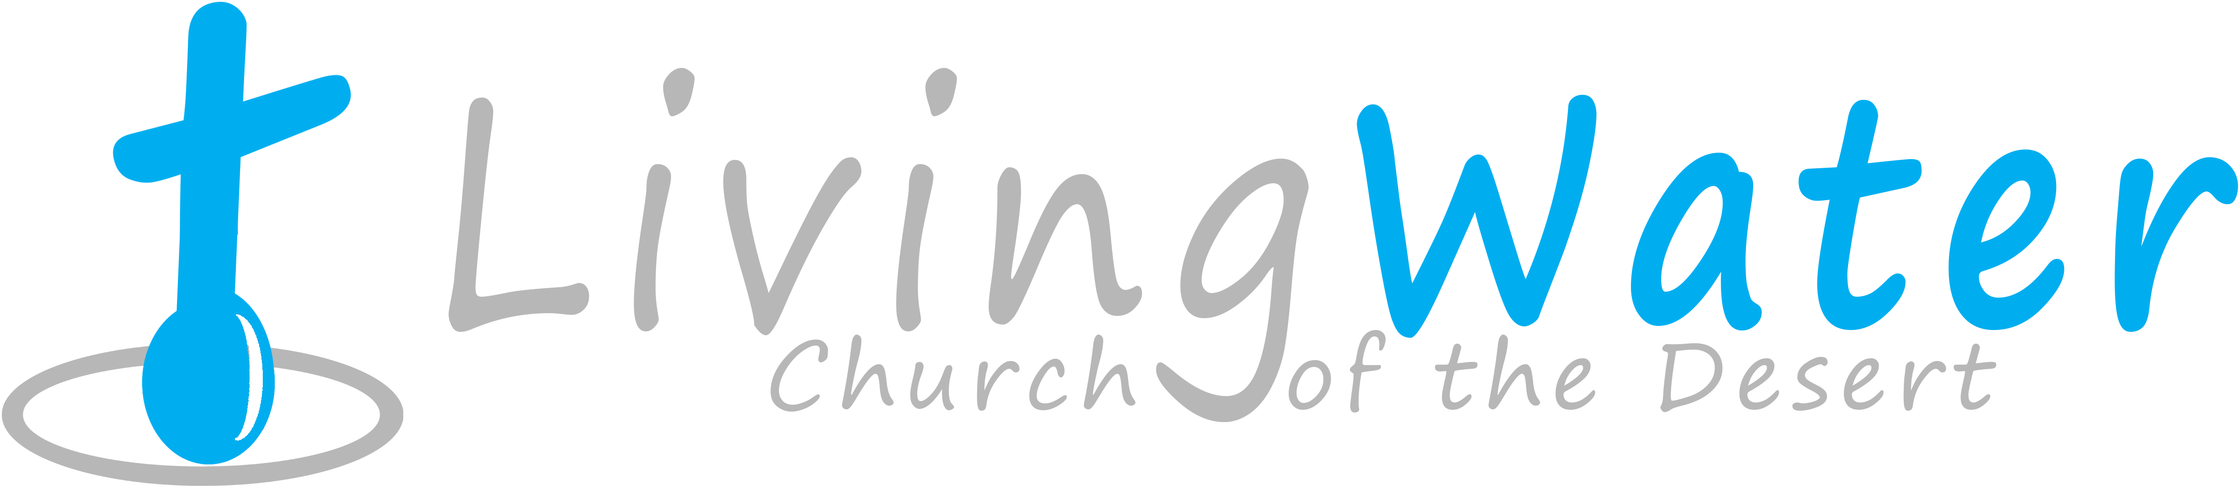8p r a y . e v a n g e l i z e . d i s c i p l e.
Nov. 13, 2016
Message: The Mystery of the Samaritan
Luke 17:11-18

OUTLINE:
1. The demand of the ten lepers.
2. The grateful heart of one leper
3. The sadness of the Lord Jesus.
4. The mystery of the Samaritan.
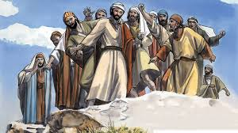

WEDNESDAY at 7 PM: The Book of Romans
You are invited to study the Book of Romans
1. The Law of the Spirit of new life
2. The Law of the sin and of death
3. The Life led by the Spirit of God
4. The Death of the flesh by the Spirit
5. The Glory of God in great suffering
6. The First fruit of the Holy Spirit.
7. The Prayer’s help by the Holy Spirit.

Thanksgiving Food Distribution
We will celebrate the thanksgiving soon, Please, donate food for this event as the Lord is leading you. The distribution of food will take place on Nov. 20, 2016 after the worship service.

SCHEDULE FOR THIS WEEK
Wednesday 6 pm- Prayer Service.
Nov. 16 7 pm- Worship Service and study of the Book of Romans
8 pm- Fellowship on every Wednesday.

Thursday 7 pm- Street Fair University in Downtown in front
Nov. 17 of the Sonny Bono Statue.

Saturday Please, pray for the Sunday Service using Bible verses.
Nov. 19

Sunday 9 am- Prayer Service.
Nov. 20 10am-Worship Service.
10am- Children Ministry from 10am until 11:10 am.
Fellowship after every service.
10:30am-Youth Ministry until 11:30 am.

Are you ready to be baptized? Please fill out the connection card.

THANKSGIVING Food Distribution
We will celebrate thanksgiving soon and would like to serve our community. If you would like to donate food, please, consider bringing items as: frozen turkey, mashed potatoes, apple pie, pumpkin pie, Cranberry juice, canned food, green beans, corn, olive oil, vegetable oil, etc. Also bring a grateful heart and a friend. Thank you!
SERVANTHOOD-Let us know if you would like to help in the church with the cleaning, ushering, prayer for the Sunday service or Wednesday service, evangelism, parking lot on Sunday’s morning for 25 minutes or setting the table with refreshments on Wednesday or Sunday. Fill out the connection card today.
Fill out the connection card today to enroll in the disciple class.
Street Fair University: If you would like to be a part of the evangelistic team on Thursday evening (7PM), please let us know. Please, fill out the connection card. If you have any questions feel free to contact Pastor George or Lucia.

Living Water Church
500 Calle San Raphael #c5 info@livingwaterps.org
Palm Springs, CA 92264 (760) 898-5848

