p r a y . e v a n g e l i z e . d i s c i p l e.
Nov. 20, 2016
Message: Grateful for our Salvation
Psalm 107

OUTLINE:
Grateful for our Salvation
1. The believer is grateful for God's redemption.
2. The believer is grateful for God's deliverance.
3. The believer is grateful for God's true healing.
4. The believer is grateful for God's vast harvest.
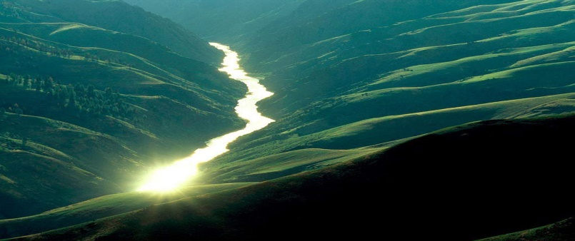

WEDNESDAY at 7 PM: The Book of Romans
Discipleship: "And Jesus took the five loaves and the two fish, and looking up to heaven, He blessed and broke and gave the loaves to the disciples; and the disciples gave to the multitudes. Matt 14:19. The multiplication began in Jesus' hands and continued as the disciples gave it to the hungry people. Are you a part of the multiplication process? Only as we give in God's kingdom, our resources will be multiplied.

Thanksgiving Food Distribution
We will celebrate the thanksgiving soon, Please, donate food for this event as the Lord is leading you. The distribution of food will take place on Nov. 20, 2016, Sunday after the worship service.
SCHEDULE FOR THIS WEEK
Wednesday 6 pm- Prayer Service.
Nov. 23 7 pm- Worship Service and study of the Book of Romans
8 pm- Fellowship on every Wednesday.

Thursday 7 pm- Street Fair University in Downtown in front
Nov. 24 of the Sonny Bono Statue.

Saturday Please, pray for the Sunday Service using Bible verses.
Nov. 26

Sunday 9 am- Prayer Service.
Nov. 27 10am-Worship Service.
10am- Children Ministry from 10am until 11:10 am.
Fellowship after every service.
10:30am-Youth Ministry until 11:30 am.

Are you ready to be baptized? Please fill out the connection card.

Key Verse: Dan 6:10.
¹⁰ Now when Daniel knew that the writing was signed, he went home. And in his upper room, with his windows open toward Jerusalem, he knelt down on his knees three times that day, and prayed and gave thanks before his God, as was his custom since early day."

SERVANTHOOD-Let us know if you would like to help in the church with the cleaning, ushering, prayer for the Sunday service or Wednesday service, evangelism, parking lot on Sunday’s morning for 25 minutes or setting the table with refreshments on Wednesday or Sunday. Fill out the connection card today.
Fill out the connection card today to enroll in the disciple class.
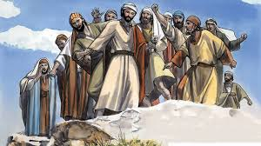
Street Fair University: If you would like to be a part of the evangelistic team on Thursday evening (7PM), please let us know. Please, fill out the connection card. If you have any questions feel free to contact Pastor George or Lucia.

Living Water Church
500 Calle San Raphael #c5 info@livingwaterps.org
Palm Springs, CA 92264 (760) 898-5848

