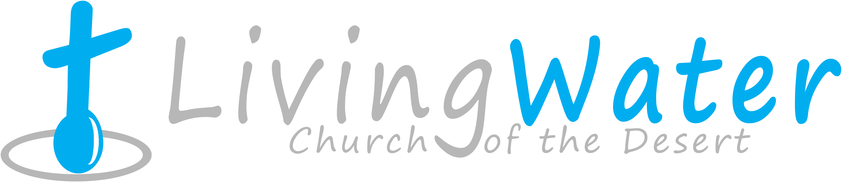p r a y . e v a n g e l i z e . d i s c i p l e.
Dec4, 2016
Message: Triple Conquest According to Jesus
Luke 17:1-20

Outline
1. Clemency according to Jesus
2. Gratitude according to Jesus.
3. Worship according to Jesus.
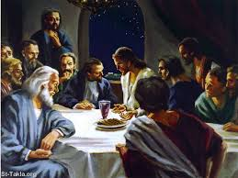
.

WEDNESDAY at 7 PM: The Book of Romans
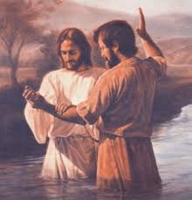
We are praying and fasting for
a revival in our church on
Monday, Wednesday and
Saturday. Saturday we start to
pray at 11 AM. Please, pray
with us and fill the connection
card if you join us in prayer.

SCHEDULE FOR THIS WEEK

Wednesday 6 pm- Prayer Service.
Dec. 7 7 pm- Worship Service and study of the Book of Romans
8 pm- Fellowship on every Wednesday.

Thursday 7 pm- Street Fair University in Downtown in front
Dec. 8 of the Sonny Bono Statue.

Saturday Please, pray for the Sunday Service using Bible verses.
Dec. 10

Sunday 9 am- Prayer Service.
Dec. 11 10am-Worship Service.
10am- Children Ministry from 10am until 11:10 am.
Fellowship after every service.
10:30am-Youth Ministry until 11:30 am.

Are you ready to be baptized? Please fill out the connection card.

SERVANTHOOD-Let us know if you would like to help in the church with the cleaning, ushering, prayer for the Sunday service or Wednesday service, evangelism, parking lot on Sunday’s morning for 25 minutes or setting the table with refreshments on Wednesday or Sunday. Fill out the connection card today.
Fill out the connection card today to enroll in the disciple class.
Street Fair University: If you would like to be a part of the evangelistic team on Thursday evening (7PM), please let us know. Please, fill out the connection card. If you have any questions feel free to contact Pastor George or Lucia.

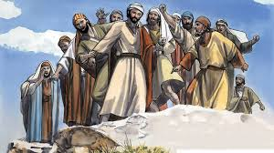

Living Water Church
5000 Calle San Raphael #c5 info@livingwaterps.org
Palm Springs, CA 92264 (760) 898-5848

