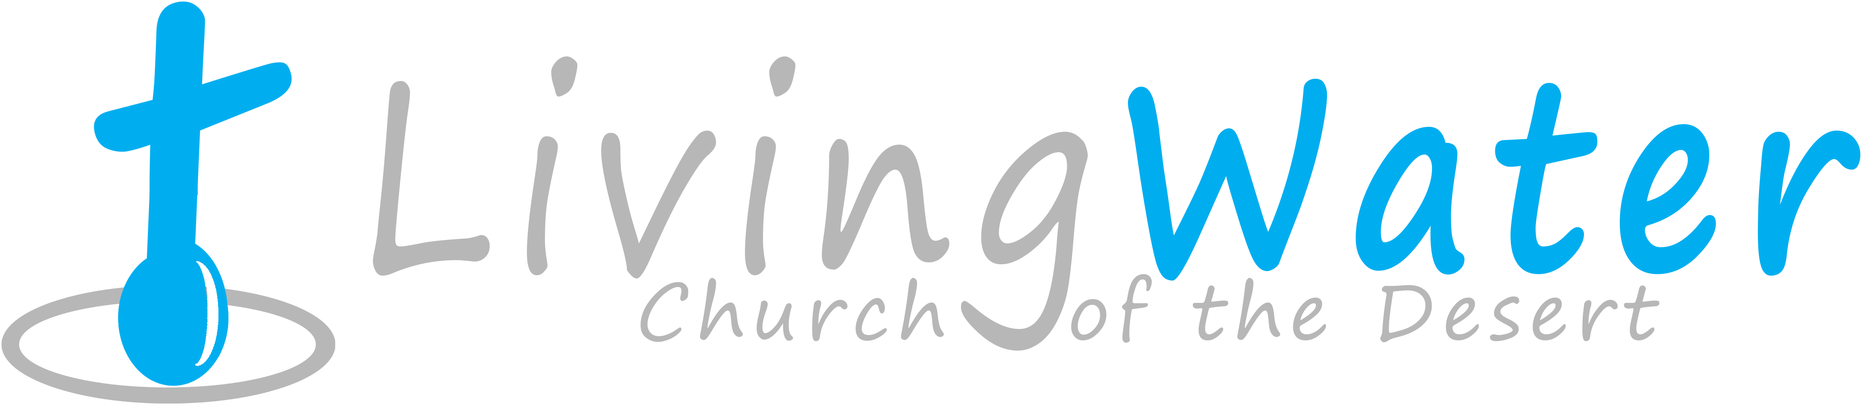p r a y . e v a n g e l i z e . d i s c i p le
Dec. 11, 2016
Message: Jesus Before Bethlehem
John 8:48-59

Outline
1. Jesus in the time of Abraham
2. Jesus in the time of Samson
3. Jesus in the time of Ezekiel
4. Jesus in the time of Augustus.
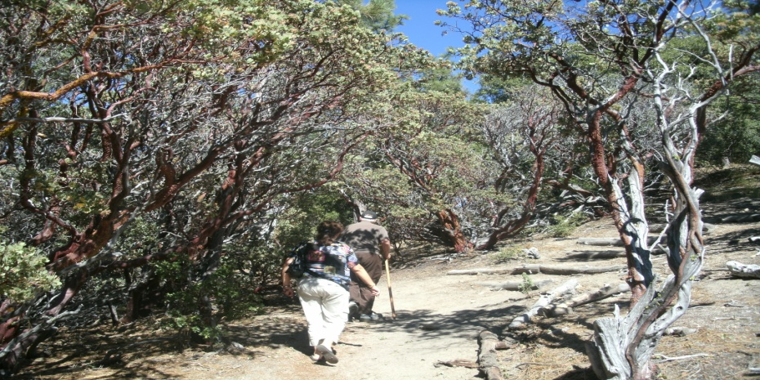
.

WEDNESDAY at 7 PM: The Book of Romans

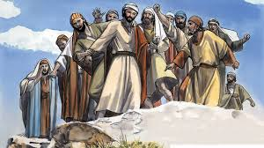
We are praying and fasting
for revival in our church in
Monday, Wednesday and
Saturday. Saturday we pray
at 11 AM. Please, pray daily
with us and fill the connection
card if you join us in prayer.

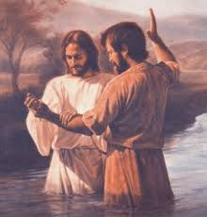
Are you ready to be baptized?
Please fill out the connection card.

Ministries -Let us know if you would like to be involved with ministry as prayer for the Sunday service or Wednesday service, evangelism, parking lot on Sunday’s morning or setting the table with refreshments on Wednesday or Sunday. Please, fill out the connection card today.
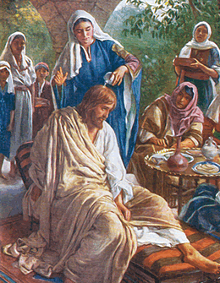
The Real Worship of Mary of Bethany
Mary of Bethany poured the expensive
perfume on Jesus’s head and prepared
His body for burial. While the disciples
were confused Mary of Bethany gave
sacrificially and Worshiped Jesus.
Fill out the connection card today to enroll in the disciple class.
SCHEDULE FOR THIS WEEK

Wednesday 6 pm- Prayer Service.
Dec. 14 7 pm- Worship Service and study of the Book of Romans
8 pm- Fellowship on every Wednesday.

Thursday 7 pm- Street Fair University in Downtown in front
Dec. 15 of the Sonny Bono Statue.

Saturday Please, pray for the Sunday Service using Bible verses.
Dec. 17

Sunday 9 am- Prayer Service.
Dec. 18 10am-Worship Service.
10am- Children Ministry from 10am until 11:10 am.
Fellowship after every service.
10:30am-Youth Ministry until 11:30 am.

Living Water Church
5000 Calle San Raphael #c5 info@livingwaterps.org
Palm Springs, CA 92264 (760) 898-5848

