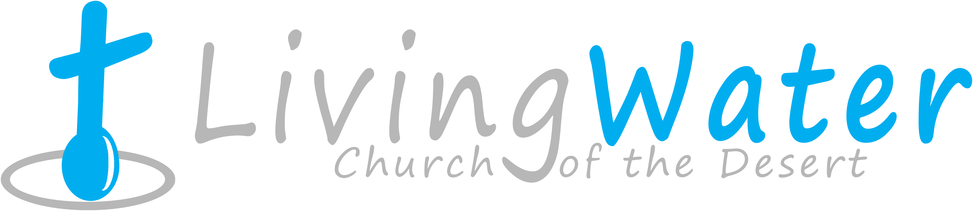p r a y . e v a n g e l i z e . d i s c i p l e.
May 1, 2016
Message: The Prayer of 120 disciples
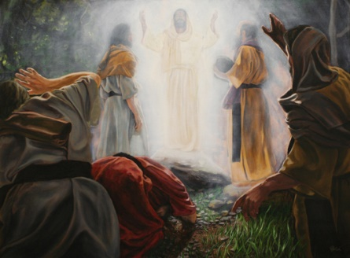
1. The promise of the Father
2. The prophecy of ascension
3. The prayer of the disciples
4. The prayer to replace Judas
Bible Text: Acts 1:1-26
Key Word=”power”-“dunamis”
The Book of Ezekiel on Wednesday at 7 PM

National Day of Prayer on May 5, 2016
Schedule for this week
1. Wednesday Service on May 4th. Prayer starts at 6pm, Worship Service starts at 7 PM. We will be studying in the Book of Ezekiel.
2. Street Fair University, Thursday night in Downtown on May 5th, at 7 PM, in front of the Sonny Bono Statue.
3. Bible fellowship and prayer every Saturday at 11 AM. Discipleship Class at 12 noon.
4. Prayer meeting and fellowship on every Wednesday at 6 PM.
5. Men’s Bible Study & Ladies’ Bible Study on Saturday May 7, 2016,
noon.
6. Sunday Service on May 8th^{th}, Prayer at 9am, Worship Service at 10am

Invite a friend this month to church or to have a cup of coffee with you. Let him know what Jesus did in your life. Your testimony through the power of the Holy Spirit can change a life forever. Daniel who wrote the Book of Daniel influenced millions of people for the God of Abraham, Isaac and Jacob.
Isaiah 58:8 “Then your light shall break forth like the morning, Your healing shall spring forth speedily, And your righteousness shall go before you; The glory of the Lord shall be your rear guard.”

10 Reasons to be Baptized!
1. It is a Bible command ! Mat. 28:19
2. It is the 1st step in discipleship.
3. Jesus was baptized. Luke 3:21
4. It is an act of obedience. Mat 28:19.
5. It is pleasing the Heavenly Father-Luke 3:21.
6. It is a public declaration of your faith. Rom.6
7. It is identification with Jesus burial. Rom. 6
8. It is identification with Jesus resurrection.
9. It is an act of commitment to the Great Commission.
10. It is encouraging other believers to follow Christ

Downtown Evangelism: Every Thursday we meet in front of Sonny Bono statue as the ambassadors for Christ. If you would like to be a part of the team, please, fill out the connection card today.

Feed the Poor: The church continues to help the poor almost every day of the week. If you would like to donate dry food, please drop it at the church on Sunday morning, Wednesday evening or Saturday at 11 AM.

Discipleship: Acts 3:18," But those things which God foretold by the mouth of all His prophets, that the Christ would suffer, He has thus fulfilled. ¹⁹ Repent therefore and be converted, that your sins may be blotted out, so that times of refreshing may come from the presence of the Lord, ²⁰ and that He may send Jesus Christ, who was preached to you before, ²¹ whom heaven must receive until the times of restoration of all things, which God has spoken by the mouth of all His holy prophets since the world began."

The Great Martyrdom of Believers
Because of serving the Moslems, the Syrian Muslims are turning to Christ! The remnant of Christians who remain in Iraq are committed to reach them. The Syrian believers are crucified. They hear the following words, "Convert, leave or die." In Sudan more than a million believers were killed from the beginning of the war in that country.
Lina of Bagdad , Iraq," I do not want to leave the country because God had a reason for putting me here. Even if I die because I am a Christian, I will be happy because I am dying for Jesus.! Ferhad of Bagdad," I was a Muslim, and now I am a Christian and these are my people. How can I not tell them about the hope that is in me?"

_______________________________________________________________________________________
If you have any questions feel free to contact Pastor George or Lucia.
Living Water Church info@livingwaterps.org
5000 Calle San Raphael #c5
Palm Springs, CA 92264 (760) 898-5848

