p r a y . e v a n g e l i z e . d i s c i p le
Dec. 24, 2016
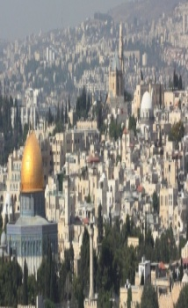
Message: The Song of Mary
Candlelight Service
Luke Chapter 2:46-56

Outline

1. The song magnifies Jesus’ salvation.
2. The song magnifies Jesus’ holiness.
3. The song magnifies Jesus’ strength.
4. The song magnifies Jesus’ provision.
5. The song magnifies Jesus’ prophecy.
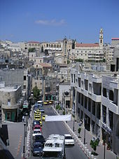
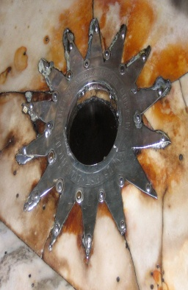
.

The Book of Romans on Wednesday at 7 PM
Mark your CALENDAR:
Sunday, Dec. 25th, Worship Service at 10 AM
Sunday 1, 2017- Worship Service at 11 AM

Are you ready to be baptized? Please fill out the connection card.
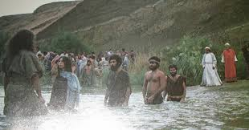

Baptism is Jesus’ command to all believers
Baptism is your declaration of real faith
Baptism is your obedience to Jesus’s word.

Pray for the peace pf Jerusalem
Fill out the connection card today to enroll in the disciple class.
SCHEDULE FOR THIS WEEK
Wednesday 6 pm- Prayer Service.
Dec. 28 7 pm- Worship Service and study of the Book of Romans
8 pm- Fellowship on every Wednesday.

Thursday 7 pm- Street Fair University in Downtown in front
Dec. 29 of the Sonny Bono Statue.

Saturday 11 Am Prayer for the sick and the church
Jan.7,2017

Sunday 9 am- Prayer Service.
Jan.8,2017 10am-Worship Service.
10am- Children Ministry from 10am until 11:10 am.
Fellowship after every service.
10:30am-Youth Ministry until 11:30 am.

Living Water Church
5000 Calle San Raphael #c5 info@livingwaterps.org
Palm Springs, CA 92264 (760) 898-5848

