p r a y . e v a n g e l i z e . d i s c i p le
Jan 1, 2017
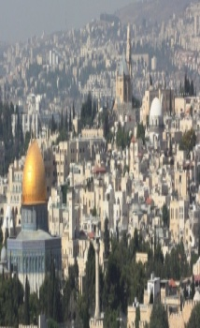
Message: God’s Plan for You in 2017
Matthew 15:22-32 11 A.M.
Happy New Year!!
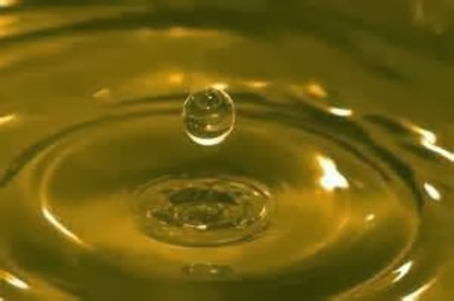

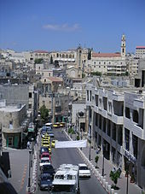
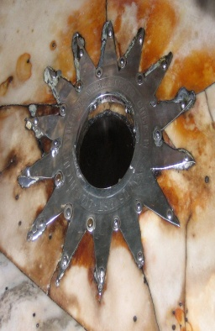
.

Outline
1. The worship of Messiah the Lord.
2. The warfare to stand in the Lord.
3. The marriage supper of the Lord.

The Book of Romans on Wednesday at 7 PM

Mark your CALENDAR:

Sunday 8, 2017- Worship Service at 11 AM
We CHANGED to 11 AM the time of Worship Service
for Sundays in 2017.
Daniel’s fasting will begin on Jan. 8th and end on Jan.29th.

Are you ready to be baptized? Let us know today!
Did you make any resolutions for the New Year?
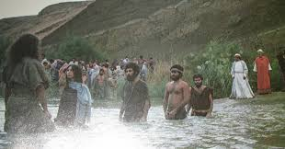 1. I will serve the Lord.
2. I will read the entire Bible!
3. I will give generously
4. I will study God's Word
5. I will improve my marriage
6. I will teach my kids!
7. I will bless the church!
8. I will live a new life
9. I will memorize the Word.
10. I will visit hospitals.
11. I will be a soul winner.
12. I will do Daniel fasting.

SCHEDULE FOR THIS WEEK
Wednesday 6 pm- Prayer Service.
2017 7 pm- Worship Service and study of the Book of Romans
8 pm- Fellowship on every Wednesday.

Thursday 7 pm- Street Fair University in Downtown in front
of the Sonny Bono Statue.

Saturday 11 Am Prayer for the sick and the church

Sunday 10 am- Prayer Service.
11am-Worship Service.
11am- Children Ministry from 10am until 11:10 am.
Fellowship after every service.
11:30am-Youth Ministry until 12:15.

Living Water Church
5000 Calle San Raphael #c5 info@livingwaterps.org
Palm Springs, CA 92264 (760) 898-5848

