p r a y . e v a n g e l i z e . d i s c i p le
Jan 8, 2017
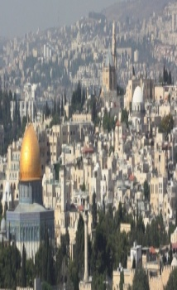
Message: “First Things First in 2017”
Matthew 6:1-25 11 A.M.
Happy New Year!!

1. When you give God will reward you.
2. When you pray God will reward you
3. When you fast God will reward you.
4.When you trust God will reward you.
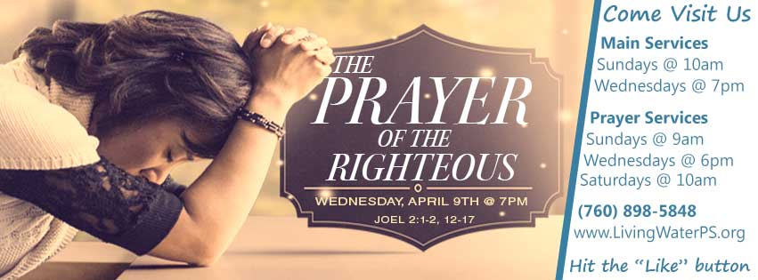
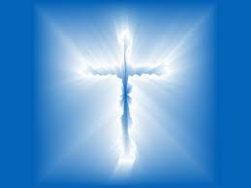

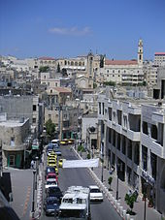
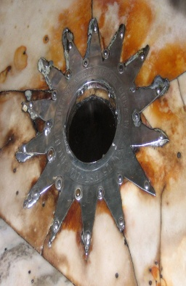
.

The Book of Romans on Wednesday at 7 PM
Receive the certificate for the Book of Romans!

Sunday 15, 2017- Worship Service at 11 AM
We CHANGED to 11 AM the time of Worship Service
for Sundays in 2017.
Daniel’s fasting will begin on Jan. 8th and end on Jan.29th.

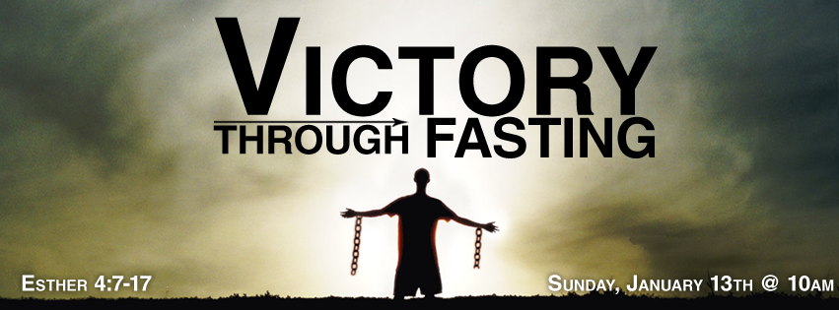

.

DANIEL’s fasting begins today Jan. 8th and will end on Jan. 29th. This fasting is described in the Book of Daniel chapters 1 and 10 when Daniel fasted 21 days,” In those days I, Daniel, was mourning three weeks. I ate no pleasant food, no meat, or wine came into my mouth, not did I anoint myself at all, until three whole weeks were fulfilled. …I lifted my eyes and looked, and behold a certain man clothed in linen, whose waist was girded with gold of Uphaz! . His body was like beryl , His face was like the appearance of lightening, His eyes like torches of fire..”Daniel 10:1-6.
SCHEDULE FOR THIS WEEK
Wednesday 6 pm- Prayer Service.
2017 7 pm- Worship Service and study of the Book of Romans
8 pm- Fellowship on every Wednesday.

Thursday 7 pm- Street Fair University in Downtown in front
of the Sonny Bono Statue.

Saturday 11 Am Prayer for the sick and the church

Sunday 10 am- Prayer Service.
11am-Worship Service.
11am- Children Ministry from 11am until 12:10 am.
Fellowship after every service.
11:30am-Youth Ministry until 12:15.

Living Water Church
5000 Calle San Raphael #c5 info@livingwaterps.org
Palm Springs, CA 92264 (760) 898-5848

