p r a y . e v a n g e l i z e . d i s c i p le
Feb 12, 2017
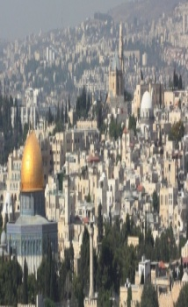
Message: ”The Language of Love”
1 Corinthians 13:1-8
“Christ we preach, warning every man and teaching every man in all wisdom to present every man perfect in Christ.”
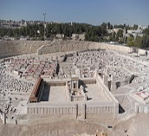
OUTLINE:
1. Love suffers long ,
2. Love is kind;
3. Love does not envy;
4 Love it is not proud
5. Love does not parade itself,
6. Love doesn't behave rudely,
7. Love does not seek its own,
8. Love is not provoked,
9. Love thinks no evil
10. Love rejoices in the truth;
11. Love bears all things,
12. Love believes all things,
13. Love hopes all things,
14. Love endures all things
15. Love will never fail.

Wednesday at 7 PM we study the Book of 1 Thessalonians
The Living Water Church invites you to become a follower of Jesus Christ (or a disciple) who knows the Word of God and is praying daily for himself, his family and the Jesus’s Church.

1.Discipleship: "And Nicodemus... also came bringing a mixture of myrrh and aloes.. "John 19:39. Nicodemus helped with the burial of Jesus. A real disciple is loyal, faithful, generous, helping and loving in the crucial time of the ministry. Nicodemus served the Lord even when he did not understand Jesus' vision for us.

CONGRATULATION to all who received the CERTIFICAT of COMPLETION for the Book of ROMANS on Feb. 8th.

2. SPREAD the GOSPEL in 2017 ! Invite your family, friend,
coworkers, mother , father to hear the gospel of Christ!
In the Lord’s prayer we read, Thy kingdom come, Thy will be done, on earth as it is in heaven.” When we get involved in the soul harvest we become an answer to the Lord’s Prayer!
3. Baptism. Are you ready to be baptized? Fill out the connection card.
‘Go and make disciples of all nations baptizing… them and teaching them to observe all things that I have commanded you” Mat:28:19.

SCHEDULE FOR THIS WEEK
Wednesday 6 pm- Prayer Service.
2017 7 pm- Worship Service and study of the Book of 1 Thessalonians
8 pm- Fellowship on every Wednesday.

Thursday 7 pm- Street Fair University in Downtown in front
of the Sonny Bono Statue.

Saturday 11 Am Prayer for the sick, the church and revival.

Sunday 10 am- Prayer Service.
11am-Worship Service.
11am- Children Ministry from 11am until 12:10 am.
Fellowship after every service.
11:30am-Youth Ministry until 12:15.

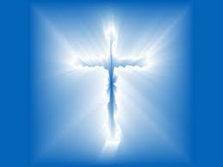
Living Water Church
5000 Calle San Raphael #c5 info@livingwaterps.org
Palm Springs, CA 92264 (760) 898-5848

