p r a y . e v a n g e l i z e . d i s c i p le
Feb 26, 2017
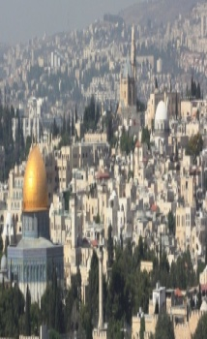
Message: The Cripple’s Man Miracle
John 5:1-15
“Christ we preach, warning every man and teaching every man in all wisdom to present every man perfect in Christ.”
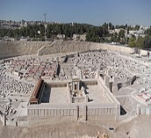
OUTLINE: John 5:1-15
1. The cripple man met the Savior
2. The cripple man met the Healer
3. The cripple man met the critics
4. The cripple man met the Christ.
Downtown Evangelism
Every Thursday at 7pm, we meet in front of the Sonny Bono statue as ambassadors for Christ. If you would like to be a part of the team, please, fill out the Connection Card today and drop it in the offering basket. We are thankful for Walter, Saul, and Lucia, Barbara as ambassadors of Jesus Christ.
Feeding the Poor
Our church continues to help the poor almost every day of the week. If you would like to donate non-perishable food, please drop it off at the church on Sunday mornings at 11 AM, Wednesday evenings at 7 PM, or Saturdays at 11am.
Water Baptism-Why should I be baptized?
1. Jesus has commended us in the Great Commission to be baptized.
2. Jesus was baptized in water and the Holy Spirit descended on Him.
3. It’s your declaration of faith to follow Christ and be a His disciple.
________________________________________________________________
Wednesday Worship Service
We study the Book of 1 Thessalonians at 7 PM
This is a book that will really help you to know Jesus Christ.

Reaching the lost:
Helen Cadbury was 12 years old when she accepted Jesus as her personal Savior. She had a great desire to witness for Jesus. Helen used to carry a large Bible with her. Her father gave her a small New Testament that was easily carried everywhere. She became an example for her friends who also got the New Testament. Helen and her friends were called the Pocket Testament League and gave away New Testament to everyone who was interested to read it. The Pocket New Testament became a strong ministry with millions of members. And all began with a young student who loved to spread the gospel using God's Word.
Pray for;
- The protection of the families represented in our church.
- For every believer in the church to become an ambassador for Christ.
- Fruitful evangelism on Thursday in downtown Palm Springs.
- The protection of the believers in N. Korea, China, India, Iraq, Iran.
- Every believer to become a disciple of the Lord Jesus Christ.

"INVITE a FRIEND" in this month . John 15:8-"By this my Father is glorified, that you bear much fruit; so will be my disciples." A definite trait of a disciple is his love for lost. Make a list of at least five friends, pray for them daily and then invite them to a worship service. You will bear fruit based on God's Word.

SCHEDULE FOR THIS WEEK

Wednesday 6 pm- Prayer Service.
2017 7 pm- Worship Service and study of the Book of 1 Thessalonians
8 pm- Fellowship on every Wednesday.

Thursday 7 pm- Street Fair University in Downtown in front
of the Sonny Bono Statue.

Saturday 11 Am Prayer for the sick, the church and revival.

Sunday 10 am- Prayer Service.
11am-Worship Service.
11am- Children Ministry from 11am until 12:10 am.
Fellowship after every service.
11:30am-Youth Ministry until 12:15.
Living Water Church
5000 Calle San Raphael #c5 info@livingwaterps.org
Palm Springs, CA 92264 (760) 898-5848

