p r a y . e v a n g e l i z e . d i s c i p le
March 12, 2017
‘Jesus stood and cried out, saying,” If anyone thirsts let him come to Me and drink. He who believes in Me …out of his heart will flow rivers of living water,” John 7:37-38.

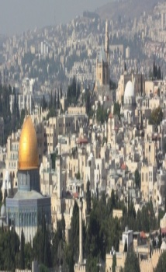
Message: “Unity According to the Bible”
Ephesians # 4
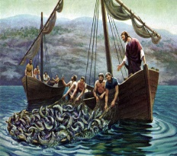
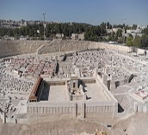
1. The saints' unity through God's body.
2. The saints' unity through God's work.
3. The saints' unity through God's mind.
4. The saints' unity through God's Spirit.

Discipleship-Get the lost at any cost to Christ! Lina of Bagdad says:" I do not want to leave the country because God had a reason for putting me here. Even if I die because I am a Christian, I will be happy because I am dying for Jesus.!
Ferhad of Bagdad," I was a Muslim, now I am a Christian and these are my people. How can I not tell them about the hope that is in me?" The vision of these Christians is to get the Muslims in the church!

CHRIST in us: PRIDE or Humility?
1. Pride is the greatest sin of all and we must avoid it daily! Ezek. 28.
2. Pride led Satan to his fall and is called also the Slanderer-... Rev.12:10
3. Pride leads to destruction and a haughty spirit before a fall - Pv.16:18
4. Pride leads to strife but the wise believers receive wisdom -Pv.13:11.
5. The humble servant is the greatest in the kingdom of God - Mt. 23:11
6. The humble is exalted and promoted by the Lord Himself - Mt. 23:12
7. The humble receive rest from Jesus who is gentle and lowly.Mt.11:28
8. The humblest servant of all times is the Lord Jesus Christ -..Lk. 22:27.
____________________________________________________________
Wednesday Worship Service 7 PM
Prayer meeting at 6 PM
We study the Book of 1 Thessalonians at 7 PM
This is a book that will really help you to know Jesus Christ and
understand the Bible concerning the end time.

Pray for:
- For every believer of the church to become an ambassador for Christ.
- For every believer to develop a daily relationship with Christ.
- For every believer to represent Christ’s attitude by the Holy Spirit.
- For every believer in the countries where persecution is going on.
- For every believer to become a disciple of the Lord Jesus Christ.

SCHEDULE FOR THIS WEEK
Wednesday 6 pm- Prayer Service.
2017 7 pm- Worship Service and study of the Book of 1 Thessalonians
8 pm- Fellowship on every Wednesday.
Thursday 7 pm- Street Fair University in Downtown in front
of the Sonny Bono Statue.
Saturday 11 Am Prayer for the sick, the church and revival in Coachella Valley.
Sunday 10 am-Prayer Service
11 am-Worship Service
11am- Children Ministry from 11am until 12:10 am.
11:30 am-Youth Ministry until 12:15.
Food for the Poor: We collect food for the poor. You can bring food on Sunday morning or Wednesday evening at 7 PM. Isaiah 58:10," If you extend your soul to the hungry ,And satisfy the afflicted soul, Then your light shall dawn in the darkness, And your darkness shall be as the noonday.¹¹ The Lord will guide you continually, And satisfy your soul in drought, And strengthen your bones."
David Brainerd was born on April 20, 1718 in Haddam, New York. His life among the Indians in North America inspired John Wesley, William Carey and Oswald Smith. David favored verse was John 7:37," He who believes out of his heart will flow rivers of living water." As he preached from Luke 14, the Holy Spirit fell upon the Indians like a rushing wind and a great torrent of water. The fire of the Lord fell like in the day of Pentecost. In 1746, at Crossweeksung there were more than 150 Indians who became Christians. The Indians were crying and prayed sometimes the whole night. It was a great victory followed by sickness due to his intense traveling and poor diet.
In 1747, David visited Jonathan Edwards in Massachusetts, being engaged to his daughter Jerusha. But David was so weak that he couldn't sit up in the bed. He went to be with the Lord on Oct. 8,1748.
Water Baptism-Why should I be baptized?
1. Jesus has commended us in the Great Commission to be baptized.
2. Jesus was baptized in water and the Holy Spirit descended on Him.
3. It’s your declaration of faith to follow Christ and be a His disciple
Living Water Church
5000 Calle San Raphael #c5 info@livingwaterps.org
Palm Springs, CA 92264 (760) 898-5848

