p r a y . e v a n g e l i z e . d i s c i p le
April 2, 2017
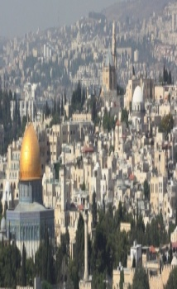
Message: The Savior We Worship
John 4:1-30
“Christ we preach, warning every man and teaching every man in all wisdom to present every man perfect in Christ.”
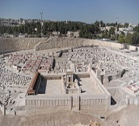
OUTLINE: John 4:1-30
Key Words: "Key Word-“grace”-the unmerited favor of God.
Bible Text: John 4:1-30
Outline:
1. Jesus Christ, the Savior of all sinners.
2. Jesus Christ, the Savior who satisfies.
3. Jesus Christ, the Savior who delivers.
4. Jesus Christ, the Savior we’ll worship.

Schedule for this coming April 2017.
April 9 -Palm Sunday Worship at 10 am.
April 14- Good Friday Worship at 12 noon.
April 16 -Resurrection Day Worship at 10 am

You are invited to worship the Lord with us every Wednesday at 7 PM. The study of the work of the Book of 1 Thessalonians 7PM continues with chapter 4, “The “Rapture” which is Greek is “harpazo.” We pray God’s power in your life and that you may grow from faith to faith and from glory to glory.
The Bible is the Word of God which includes more than seven thousand promises. Here is one of them;” If you confess with your mouth the Lord Jesus and believe in your heart that God raised Him from the dead you will be saved.”
Come and be blessed by Jesus’ Word and the power of the Holy Spirit!

Wednesday Worship Service 7 PM
We study the Book of 1 Thessalonians at 7 PM
Study with us the RAPTURE of the church.
Schedule for April 2017
- April 5-Wednesday- Service at 7 PM, We study 1 Thessalonians;
- April 6-Thursday-Downtown Evangelism-7 PM, at Sonny Bono Statue
- April 7-Friday -Fasting day for the church-Isaiah 53.
- April 8-Saturday-Prayer Meeting & Teaching at 10 AM.
- April 9-Sunday, Palm Sunday Service at 10 AM.
- April 12-Wednesday-Worship Service at 7 PM.
- April 14-Good Friday Service at 12 AM-noon time.
- April 15-Prayer at 11 AM before the Resurrection Day. April 16, Sunday at 10 AM-Worship Service-"The Resurrection of Jesus."
Hero of Faith: Bill Bright the founder of the Campus Crusade for Christ wrote a booklet entitled "The 4 Spiritual Laws" and used Jesus' movie to lead people to Christ worldwide. This booklet is the most read booklet in the world. One hundred fifty million people accepted the Lord. Bill Bright made a covenant with the Lord when he was 17," I do not have any rights…I surrender all in your hand. "I am thankful whatever place you send me, I will go."
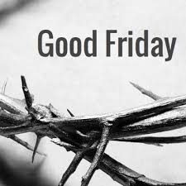
Are you ready to celebrate the Good Friday? It is the Day when
Jesus paid for our sins on the cross and our live was changed
forever. We pray that you will be ready spiritually for this DAY
and celebrate what Jesus did for us! He paid in full for our sins
and cried with a loud voice,” It is finished.” You will find out on April 14, Friday, how many prophecies Jesus fulfilled in that day when the sun was dark!

JESUS Reveals Himself as the Messiah
John 4:19-26 -¹⁹ The woman said to Him, "Sir, I perceive that You are a prophet.
²⁰ Our fathers worshiped on this mountain, and you Jews say that in Jerusalem is the place where one ought to worship."
²¹ Jesus said to her, "Woman, believe Me, the hour is coming when you will neither on this mountain, nor in Jerusalem, worship the Father.
²² You worship what you do not know; we know what we worship, for salvation is of the Jews. ²³ But the hour is coming, and now is, when the true worshipers will worship the Father in spirit and truth; for the Father is seeking such to worship Him. ²⁴ God is Spirit, and those who worship Him must worship in spirit and truth." ²⁵ The woman said to Him, "I know that Messiah is coming" (who is called Christ). "When He comes, He will tell us all things." ²⁶ Jesus said to her, "I who speak to you I am He."

Living Water Church
5000 Calle San Raphael #c5 info@livingwaterps.org
Palm Springs, CA 92264 (760) 898-5848

