p r a y . e v a n g e l i z e . d i s c i p le
April 9, 2017
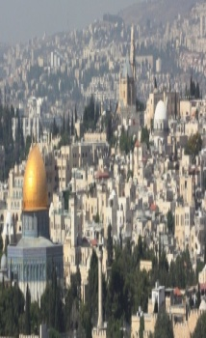
Message: Five Reasons Jesus Entered Jerusalem
Matthew 21:-1-11
Have a godly Palm Sunday in the Lord!

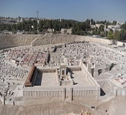
OUTLINE:
Outline: Matthew 21:1-11
1. Jesus the Servant enters Jerusalem as the King.
2. Jesus the Servant enters Jerusalem as the Lamb
3. Jesus the Servant enters Jerusalem as the Lord.
4. Jesus the Servant enters Jerusalem as the Savior
5. Jesus the Servant enters Jerusalem as the Victor

Schedule for April 2017.
April 14- Good Friday Worship at 12 noon.
April 16 -Resurrection Day Worship at 10 am
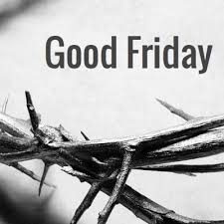
Are you ready to celebrate the Good Friday? It is the Day when
Jesus paid for our sins on the cross and our live was changed
forever. We pray that you will be ready spiritually for this DAY
and celebrate what Jesus did for us! He paid in full for our sins
and cried with a loud voice,” It is finished.” You will find out on
April 14, 12 noon 1nnoon
April 14, Friday, how many prophecies Jesus fulfilled in that day when the sun was dark!
INVITE a FRIEND" in the month of April. John 15:8-"By this my Father is glorified, that you bear much fruit; so will be my disciples." A definite trait of a disciple is his love for lost. Make a list of at least five friends, pray for them daily and then invite them to a worship service. You will bear fruit based on God's Word.
Discipleship every Wednesday from 6-7 PM and on Saturday from 11-12 AM. Jesus called us to be His disciple and His ambassadors!

Schedule for April 2017
- April 9-Sunday, Palm Sunday Service at 10 AM.
- April 12-Wednesday-Worship Service at 7 PM.
- April 14-Good Friday Service at 12 AM-noon time.
- April 15-Prayer at 11 AM before the Resurrection Day.
- April 16, Sunday at 10 AM-Worship Service-"The Resurrection of Jesus."
WEDNESDAY WORSHIP SERVICE-You are invited to worship the Lord with us every Wednesday at 7 PM. The study of the work of the Book of 1 Thessalonians 7 PM continues with chapter 5, “The DAY of the LORD.” We pray God’s power in your life and that you may grow from faith to faith and from glory to glory. The Bible is the Word of God which includes more than seven thousand promises. Come and be blessed by Jesus’ Word and the power of the Holy Spirit!

Wednesday Discipleship: We extend the discipleship program every Wednesday from 6-7PM and Saturday from 11-12 AM. Come and grow in the Lord. Colossians 3:16:"Let the word of Christ dwell in you richly in all wisdom, teaching and admonishing one another in psalms and hymns and spiritual songs, singing with grace in your hearts to the Lord. ¹⁷ And whatever you do in word or deed, do all in the name of the Lord Jesus, giving thanks to God the Father through Him."
Water Baptism: Are you ready to be baptized? The Water Baptism Service is planned to take place every month. Let us know in advanced if you would like to be baptized. Every Wednesday at 6 PM you can attend classes in order to learn more about water baptism. Jesus told us to “make disciples from all nations baptizing them in the Name of the Father, Son and Holy Spirit and teaching them to observe all things that I have commanded you and I will be with you always, even to the end of the age.” Matthew 28:19-20.
a. Paul was baptized after 3 days.
b. Jesus was baptized-Luke 3:21.
c. It is a symbol of Jesus' death and resurrection-Rom. 6:4-6.
d. The Philippi jailor was baptized at 2 AM in the morning.
e. The eunuch of Acts 8 was baptized immediately
Living Water Church
5000 Calle San Raphael #c5 info@livingwaterps.org
Palm Springs, CA 92264 (760) 898-5848

