p r a y . e v a n g e l i z e . di s c i p le
June 4, 2017
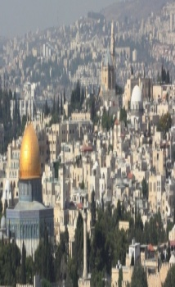
Jesus’Fourth Sign
John 6:1-14
“Jesus stood and cried out saying,’ If anyone thirsts, let him come to me and drink.” John 7:37.
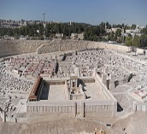
The Fourth Sign’s Message-The Master of Provision
Jesus' Multiplies the Bread -Bible Text-John 6:1-14
Outline
1. The problem of the great Shepherd
2. The planning of the great Shepherd
3. The provision of the great Shepherd
4. The medicine of the great Shepherd
The 1st sign-Jesus changed the water into wine (Master over time)
The 2nd sign-Jesus’ long distance healing…..(Master over distance)
The 3rd sign-Jesus healed a paralytic…..(Master over human body)
The 4th sign-Jesus multiplies the bread-(Master of every provision)
Schedule for June 2017
Wednesday6 pm- Prayer Service.
7 pm-Worship Serviceand the study of the Book of James.
8 pm- Fellowship on every Wednesday.
Thursday7 pm- Street Fair University in Downtown, Palm Springs.
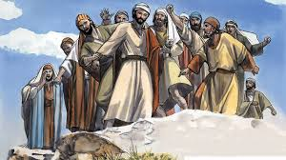
Saturday 11 am - Prayer for the sick, the church and revival in Coachella Valley.
Sunday 9 am-Prayers Service to 9:45.
10 am-Worship Service
10:30 am-Children Ministry from 10:30 am until 11:10 am.
10:30 am-Youth Ministry until 11:15.
Wednesday Worship Service
Westudy the Book of James at 7 PM.
This is a book that will really help you to knowthe wisdomof Jesus.

2. Discipleship:Col. 3:16
“Let the word of Christ dwell in you richly in all wisdom, teaching and admonishing one another in psalms and hymns and spiritual songs, singing with grace in your hearts to the Lord." A disciple is in the Word day and night. The Bible is his daily spiritual food.
3. CHOIR REHEARSAL is scheduled for Wednesday, June 7,2017 at 6 PM.
4)Water Baptism:
The Water baptism Service will take place on June 11th. Let us know in advanced if you would like to be baptized. Play for the believers that were baptized last Sunday. Every Wednesday at 6 PM you can attend classes in order to learn more about water baptism.
Water Baptism:Did you Know?
a. Paul was baptized after 3 days.
b. Jesus was baptized-Luke 3:21.
c. It is a symbol of Jesus' death and resurrection;
d.The Philippi jailor was baptized at 2 AM in the morning.
e. The eunuch of Acts 8 was baptized immediately.
5.YOU ARE INVITED: Thursday at 7 PM to be a part of The University of StreetFair. We meet at 7 PM in front of Ruby’s Restaurant, in downtown Palm Springs.
6.FEEDING THE POOR: We still continue to feed the poor. If you would like to donate food, you can do it on Wednesday from 6-8PM and on Sunday for 9-11:30 AM. The Church has a food pantry after Wednesday Worship Service for those families that are in need. Any food donations are really appreciated. Remember Proverbs 10:3," The Lord will not allow the righteous to hunger…"
7. The Believers' Multiplication:
1. It is God's plan for every believer 8. It will change your life forever.
2. It is included in the Great Commission. 9. It includes a daily satisfaction;
3. It is done through the Holy Spirit. 10. It includes daily, sustained prayer;
4. It may require 30 minutes per day; 11. It defeats the devil’s strategies.
5. It must include God’s living Word; 12. It brings a revival in your life;
6. It has an eternal, powerful reward 13. It leads you closer to the Jesus.
7. It is God’s vision for the church. 14. You will shine like stars the forever!
6.Discipleship:Every Wednesday from 6-7 PM and on Saturday from 11-12 AM. Jesus called us to be His disciple and His ambassadors!
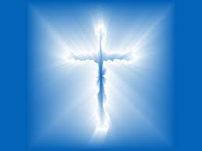
Living Water Church
info@livingwaterps.org
Palm Springs, CA(760) 898-5848

