p r a y . e v a n g e l i z e . di s c i p le
May 30, 2017
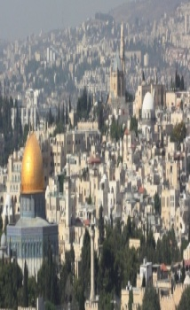
Jesus’Third Sign
John 5:1-12
“Jesus stood and cried out saying,’ If anyone thirsts, let him come to me and drink.” John 7:37.
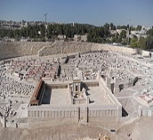
The Third Sign’s Message-OUTLINE
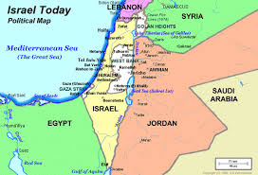
1. Thecripple man’s dialog with the Lord.
2. The cripple man’s dialog with the critics.
3. Thecripple man’s dialog with the Savior
4. Thecripple man’s cure reveal His glory.
The 1st sign-Jesus changed water into wine(time)
The 2nd sign-Jesus’ long distance healing (distance)
The 3rd sign-Jesus healed a paralytic (muscles dried-up)
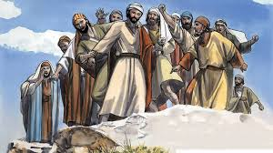

Wednesday Worship Service
Westudy the Book of James at 7 PM.
This is a book that will really help you to knowthe wisdomof Jesus.

Water Baptism:Did you Know?
a. Paul was baptized after 3 days.
b. Jesus was baptized-Luke 3:21.
c. It is a symbol of Jesus' death and resurrection;
d.The Philippi jailor was baptized at 2 AM in the morning.
e. The eunuch of Acts 8 was baptized immediately.

You Are invited:Thursday at 7 PM to be a part of The Universityof StreetFair. We meet at 7 PM in front of Ruby’s Restaurant, in downtown Palm Springs.
Feeding the Poor: We still continue to feed the poor. If you would like to donate food, you can do it on Wednesday from 6-8PM and on Sunday for 9-11:30 AM. The Church has a food pantry after Wednesday Worship Service for those families that are in need. Any food donations are really appreciated. Remember Proverbs 10:3," The Lord will not allow the righteous to hunger…"

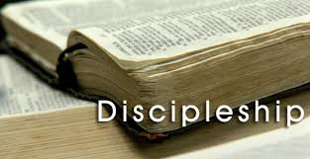
Discipleship :Every Wednesday from 6-7 PM and on Saturday from 11-12 AM. Jesus called us to be His disciple and His ambassadors!
Schedule for May 2017
Wednesday6 pm- Prayer Service.
7 pm-Worship Serviceand the study of the Book of James.
8 pm- Fellowship on every Wednesday.
Thursday7 pm- Street Fair University in Downtown, Palm Springs.
Saturday11 am - Prayer for the sick, the church and revival in Coachella Valley.
Sunday 9 am-Prayers Service to 9:45.
10 am-Worship Service
10:30 am-Children Ministry from 10:30 am until 11:10 am.
10:30 am-Youth Ministry until 11:15.

We give food every week to all who need help. If you would like to help
assisting the poor please drop the food on Sunday at 10 AM or
Wednesday at 7 PM.

Did you Know? 1. In 1948 the nation of Israel was reborn. President Henry Truman recognized Israel in less than thirty minutes. Israel became a country on May 15, 1948 and it happened in ONE day, as it was prophesied in the Bible.
Isaiah 66:8“Who has heard such a thing? Who has seen such things? Shall the earth be made to give birth in one day? Or shall a nation be born at once? For as soon as Zion was in labor, She gave birth to her children.”
2. In 1967 took place the Six Day War when Israelwas attacked by six countries. They were all defeated in six days and Jerusalem was liberated and became the capital of Israel.
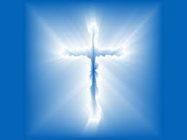
Living Water Church
info@livingwaterps.org
Palm Springs, CA(760) 898-5848

