June 18, 2017
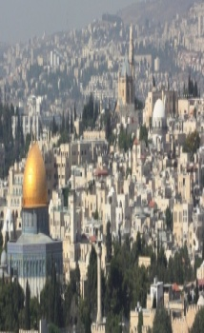
The Father of Faith
Genesis 22
“Then those who were in the boat came and worship Him, saying, ‘Truly You are the Son of God.”-Matt.14:33

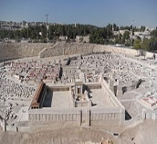
Happy Father’s Day
-Bible Text-Genesis 22
Outline
1. God isobeyed on Mount Moriah # 22:1- 4
2. God is adoredon Mount Moriah # 22:5-14
3. God is exalted on Mount Moriah # 22:15-18
ABRAHAM
1. Served -served God, served the angels, served faithfully.
2. Prayed-a man who prayed for 25 years for a child.
3. Received a vision-All nations will be blessed through you.
A father without a VISION will have a fruitless ministry.
Abraham a vision, Isaac had a vision, Noah had a vision;
4. Heardthe Lord speaking- Gen. 12, 22;
5. Received the promise- a child whose name was Isaac;
6. Believed not God’s report from the beginning.
7.Trained by the Lord for many years in the Promise Land.
Schedule for June 18-25, 2017
Wednesday6 pm- Prayer Service.
7 pm-Worship Serviceand the study of the Book of James.
8 pm- Fellowship on every Wednesday.
Thursday7 pm- Street Fair University in Downtown, Palm Springs.
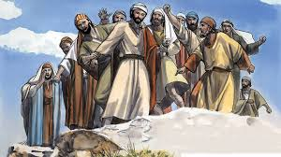
Saturday 11 am - Prayer for the sick, the church and revival in Coachella Valley.
Sunday 9 am-Prayers Service to 9:45.
10 am-Worship Service
10:30 am-Children Ministry from 10:30 am until 11:10 am.
10:30 am-Youth Ministry until 11:15.
p r a y . e v a n g e l i z e . di s c i p le
Wednesday Worship Service
Westudy the Book of James at 7 PM.
1. Wisdom is more important than gold and silver!
We will study the wisdom of James, the half brother of Jesus
We will study the wisdom of Abraham, the father of faith
We will study the wisdom of Solomon, the son of David, etc.

2.Discipleship:¹ Blessed isthe man, Who walks not in the counsel of the ungodly, Nor stands in the path of sinners, Nor sits in the seat of the scornful; ² But his delight is in the law of the Lord, And in His law he meditates day and night. Psalms 1:1-2.

3. CHOIR REHEARSAL is scheduled for Wednesday, June 21,2017 at 6 PM.

4)Water Baptism:Let us know in advanced if you would like to be baptized. Pray for the believers that were baptized last Sunday. Every Wednesday at 6 PM you can attend classes in order to learn more about water baptism.
5.YOU ARE INVITED: Thursday at 7 PM to be a part of The University of StreetFair. We meet at 7 PM in front of Ruby’s Restaurant, in downtown Palm Springs.
6.FEEDING THE POOR: We still continue to feed the poor. If you would like to donate food, you can do it on Wednesday from 6-8PM and on Sunday for 9-11:30 AM. The Church has a food pantry after Wednesday Worship Service for those families that are in need. Any food donations are really appreciated. Remember Proverbs 10:3," The Lord will not allow the righteous to hunger…"
7. Prayer and Praise and Glory!
The prayer team is always available to pray for you and your family at the end of the worship service. Also, we are available to pray for you from nine to ten on Sunday.
8.Discipleship:Every Wednesday from 6-7 PM and on Saturday from 11-12 AM. Jesus called us to be His disciple and His ambassadors!

Living Water Church
info@livingwaterps.org
Palm Springs, CA(760) 898-5848
p r a y . e v a n g e l i z e . di s c i p le

