July 2, 2017
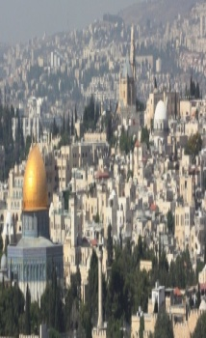
The Real Light of the World
John # 9
“Then those who were in the boat came and worship Him, saying, ‘Truly You are the Son of God.”-Matt.14:33
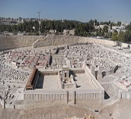

God Bless United States of America!

The Light of the Believer- John # 9

1. The blind man meets the critics.
2. The blind man meets the Savior.
3. The blind man meets his enemies.
4. The blind man needs to worship.

Schedule for June 25-July 2, 2017
Wednesday6 pm- Prayer Service.
7 pm-Worship Serviceand the study of the Book of James.
8 pm- Fellowship on every Wednesday.
Thursday7 pm- Street Fair University in Downtown, Palm Springs.
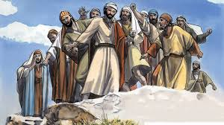
Saturday 11 am - Prayer for the sick, the church and revival in our country.
Sunday 9 am-Prayers Service to 9:45.
10 am-Worship Service
10:30 am-Children Ministry from 10:30 am until 11:10 am.
10:30 am-Youth Ministry until 11:15.
p r a y . e v a n g e l i z e . di s c i p le
Wednesday Worship Service
Westudy the Book of James at 7 PM.
Wisdom is more important than gold and silver!
We will study the wisdom of Solomon, the wisest man ever.
We will study the wisdom of David, a man after God’s own heart.
We will study the wisdom of Joshua who conquered the Promise Land.

Great Healings in the Bible:
EXAMPLES of healings in the Bible:
The healing of Naaman, the Syrian general.2 King. 5
The healing of Abimelek's servants-Gen. 20:17.
The healing of Hezekiah, the king of Israel-Isaiah 38:1-9.
The healing of Bartimeus, on the Road of Jericho.
The healing of blind born man-John #9.

2.Discipleship:³⁹ But the salvation of the righteous is from the Lord; He is their strength in the time of trouble. ⁴⁰ And the Lord shall help them and deliver them; He shall deliver them from the wicked, And save them..."Psalms 37:39-40.
3. CHOIR REHEARSAL is scheduled for Wednesday, July 5,2017 at 6 PM.
4)Water Baptism:Let us know in advanced if you would like to be baptized. Pray for the believers that were baptized last Sunday. Every Wednesday at 6 PM you can attend classes in order to learn more about water baptism.

5.YOU ARE INVITED: Thursday at 7 PM to be a part of The University of StreetFair. We meet at 7 PM in front of Ruby’s Restaurant, in downtown Palm Springs.
6.FEEDING THE POOR: We still continue to feed the poor. If you would like to donate food, you can do it on Wednesday from 6-8PM and on Sunday for 9-11:30 AM. The Church has a food pantry after Wednesday Worship Service for those families that are in need. Any food donations are really appreciated. Remember Proverbs 10:3," The Lord will not allow the righteous to hunger…"
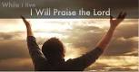
7. Prayer and Praise and Glory!
The prayer team is always available to pray for you and your family at the end of the worship service. Also, we are available to pray for you from nine to ten on Sunday.

8.Discipleship:Every Wednesday from 6-7 PM and on Saturday from 11-12 AM. Jesus called us to be His disciple and His ambassadors!

Living Water Church
info@livingwaterps.org
Palm Springs, CA(760) 898-5848
p r a y . e v a n g e l i z e . di s c i p le

