p r a y . e v a n g e l i z e . d i s c i p le
August 27, 2017
The Victory in Christ’ Deity
John 21:1-25
“Christ we preach, warning every man and teaching every man in all wisdom to present every man perfect in Christ.”
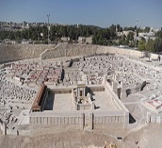

1. The fishermen’ painful loss on the Sea of Galilee
2. The fisher of men’conquest on the Sea of Galilee
3. The fisher of men is serving the hungry disciples.
4. The fisher of men is seeking more fisher of men.

Wednesday Worship Service
We study the Book of ACTS at 7 PM.
This is a book that will really help you to know the wisdom of Jesus

Be an Ambassador for Christ.
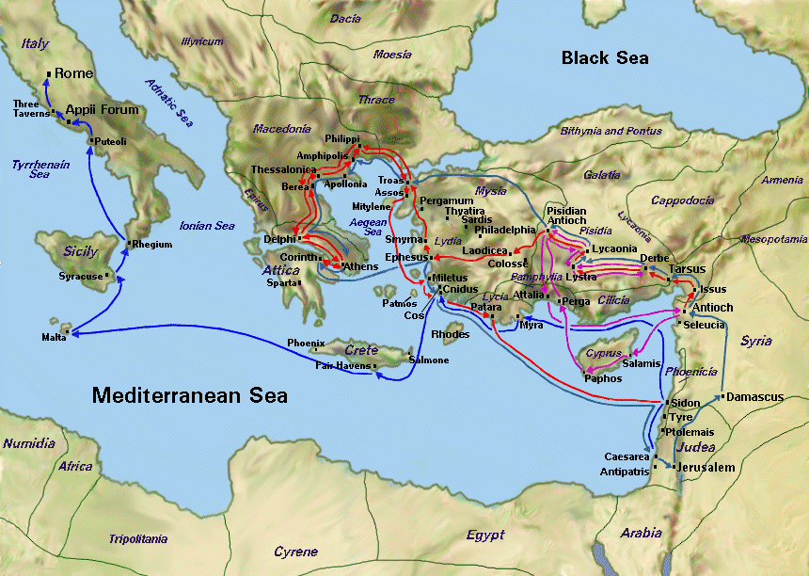
John 15:8-"By this my Father is glorified, that you bear much fruit; so you will be my disciples." Let the Lord speak to you from His Word concerning the lost.

Paul’s Journeys

Discipleship : Every Wednesday from 6-7 PM and on Saturday from 11-12 AM. Jesus called us to be His disciple and His ambassadors!

Food for the Poor: We collect food for the poor. You can bring food on Sunday morning or Wednesday evening at 7 PM. Isaiah 58:10," If you extend your soul to the hungry and satisfy the afflicted soul, Then your light shall dawn in the darkness, and your darkness shall be as the noonday.¹¹ The Lord will guide you continually, and satisfy your soul in drought, and strengthen your bones."
Schedule for August 2017

Wednesday 6 pm - Prayer Service.
7 pm - Worship Service and the study of the Book of James.
8 pm - Fellowship on every Wednesday.
Thursday 7 pm - Street Fair University in Downtown, Palm Springs.
Saturday 11 am - Prayer for the sick, the church and revival in Coachella Valley.
Sunday 9 am-Prayers Service to 9:45.
10 am-Worship Service
10 am-Children Ministry from 10am until 11:10 am.
10:30 am-Youth Ministry until 11:15.

We give food every week to all who need help. If you would like to help
assisting the poor please drop the food on Sunday at 10 AM or
Wednesday at 7 PM.
Lessons about DEITY of Jesus
1. Jesus is the great, loving, eternal Shepherd.
2. Jesus came as Lamb of God, without sin
3. Jesus is looking for more fishers of men
4. Jesus was accused as being ONE with the Father
5. Jesus got authority over all judgment of men.
6. Jesus gives life to the dead as the Father does.
7. Jesus has life in Himself and died voluntarily.
8. Jesus proved clearly His deity many times.
9. Jesus walked on the water and raised the dead.
10. Jesus’ many enemies proved also His deity.
11. Jesus and God the Father were (are) One.
12. Jesus received worshiped by His disciples.

Living Water Church info@livingwaterps.org (760) 898-5848
Palm Springs, CA 92264

