p r a y . e v a n g e l i z e . d i s c i p le
July 23, 2017
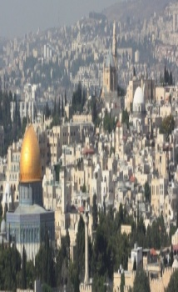
Message: “The Crucifixion Sign”
John 12:20-37
“Christ we preach, warning every man and teaching every man in all wisdom to present every man perfect in Christ.”
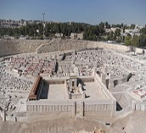
OUTLINE: John 12:20-35
1. Jesus provides the wheatgrain sign
2. Jesus provides the thundering sign
3. Jesus provides the crucifixion sign
4. Jesus provides the bright light sign

Schedule for July 27-31, 2017.
July 27, 2017-Wednesday,Worship Service at 7 PM.
July 29, 2017-Healing Prayer &Worship at 11AM
July 30, 2017-Sunday-Worship Service at 10 AM

You are invited to worship the Lord with us every Wednesday at 7 PM. The study of the wisdom subject continues with the James 5:12-20. “Step out of the Boat” and experience God’s power in your life will be the main theme of the study. Why do some people grow from faith to faith and from glory to glory?
We will answer this question using God’s Word. Remember the Niagara Falls’ tight rope walker who crossed over the falls and the whole crowd applauded him? How many were ready to volunteer and sit in the wheel barrel and cross the Niagara Falls?
Come and be blessed by Jesus’ Word and the power of the Holy Spirit!
Wednesday Worship Service 7 PM
The Book of James 5:12-20
This is a book that will impart wisdom to you!

Bible Promises
Mark 11:21-24: And Peter, remembering, said to Him, “Rabbi, look! The fig tree which You cursed has withered away.” So Jesus answered and said to them, “Have faith in God. For assuredly, I say to you, whoever says to this mountain, ‘Be removed and be cast into the sea,’ and does not doubt in his heart, but believes that those things he says will be done, he will have whatever he says. Therefore I say to you, whatever things you ask when you pray, believe that you receive them, and you will have them.
Luke 12:28-31: If then God so clothes the grass, which today is in the field and tomorrow is thrown into the oven, how much more will He clothe you, O you of little faith? “And do not seek what you should eat or what you should drink, nor have an anxious mind. For all these things the nations of the world seek after, and your Father knows that you need these things. But seek the kingdom of God, and all these things shall be added to you.
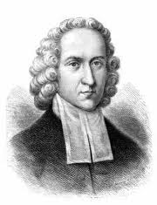
The Great Awakening
It was 1734 and immorality, debauchery and Low Church attendance made Jonathan Edwards kneel on Sunday morning and pray. Then he named in the poppet the sins; neglect of family prayer, disregard for the Lord’s Day, greediness, sensuality, etc. In December the revival began and spilled over to one hundred communities. The revival continued for twenty years and between twenty thousand and fifty thousand people became believers, which is equivalent to twenty five million in today’s population. It developed the Christian principles found in the foundation of the American government.

SCHEDULE FOR THIS WEEK
Wednesday 6 pm- Prayer Service.
2017 7 pm- Worship Service and study of the Book of 1 Thessalonians
8 pm- Fellowship on every Wednesday.

Thursday 7 pm- Street Fair University in Downtown in front
of the Sonny Bono Statue.

Saturday 11 Am Prayer for the sick, the church and revival.

Sunday 10 am- Prayer Service.
11am-Worship Service.
11am- Children Ministry from 11am until 12:10 am.
Fellowship after every service.
11:30am-Youth Ministry until 12:15.

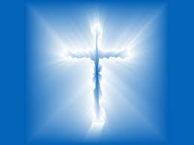
Living Water Church
5000 Calle San Raphael #c5
Palm Springs, CA 92264 (760) 898-5848

