July 30, 2017
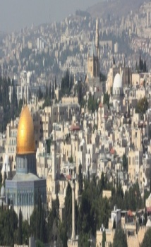
The Sign of Betrayal
John 13:18-35

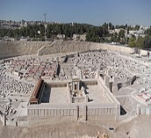
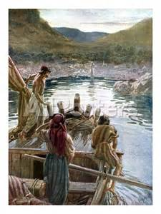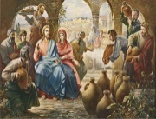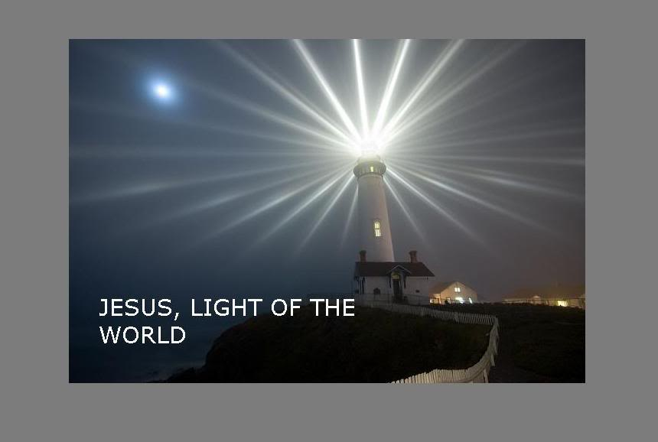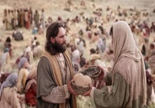

1. The Scripture about the traitor.
2. The sharing of the bread’ sign.
3. The sharing of news with John
4. The sign of the glory of the Son.
LESSONS for us!
1. Christ fulfills more prophecies about Himself.
2. Christ fulfills the perfect will of the Father.
3. Christ fulfills His great mission on earth
4. Christ fulfills the greatest commandment.
5. Christ’ prophecy spoken to the beloved disciples
6. Christ’ prophecies are changing our faith!
7. Christ’prophecies will continue to be fulfilled!
Schedule for July 30-August 3, 2017
Wednesday 6 pm - Prayer Service.
7 pm - Worship Service and the study of the Book of James.
8 pm - Fellowship on every Wednesday.
Thursday 7 pm - Street Fair University in Downtown, Palm Springs.
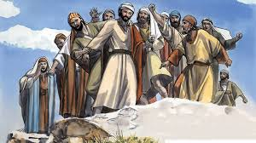
Saturday 11 am – Worship Healing Service at 11 AM
Sunday 9 am-Prayers Service to 9:45.
10 am-Worship Service
10:30 am-Children Ministry from 10:30 am until 11:10 am.
10:30 am-Youth Ministry until 11:15.
p r a y . e v a n g e l i z e . d i s c i p le
Wednesday Worship Service 7 PM
We study the Book of James at 7 PM.
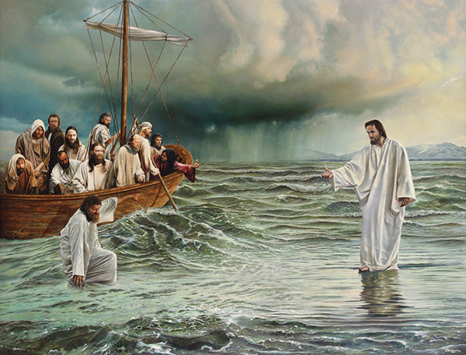 Wisdom is more important than gold and silver!
We will study the wisdom of Daniel the man of holiness;
We will study the wisdom of Esther, the woman of faith;
We will study the wisdom of Ezekiel, the man of prophecy.

2.Discipleship Mat. 4:19-20-" Then He said to them, "Follow Me, and I will make you fishers of men." ²⁰ They immediately left their nets and followed Him." Peter and Andrew obeyed and followed Jesus immediately. There was no delay and no murmuring. Jesus' disciple will become a fisher of men. Are you a fisher of men?
3 Bible Promises: Romans 8:12-15 “Therefore, brethren, we are debtors, not to the flesh, to live after the flesh. For if ye live after the flesh, ye shall die: but if ye through the Spirit do mortify the deeds of the body, ye shall live. For as many as are led by the Spirit of God, they are the sons of God. For ye have not received the spirit of bondage again to fear; but ye have received the Spirit of adoption, whereby we cry, Abba, Father."
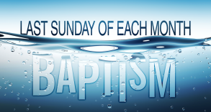
4) Water Baptism: Let us know in advanced if you would like to be baptized. Pray for the believers that were baptized last
Sunday. Every Wednesday at 6 PM you can attend
classes in order to learn more about water baptism.
5. YOU ARE INVITED: Thursday at 7 PM to be a part of The University of Street Fair. We meet at 7 PM in front of Ruby’s Restaurant, in downtown Palm Springs.
6. FEEDING THE POOR: We still continue to feed the poor. If you would like to donate food, you can do it on Wednesday from 6-8 PM and on Sunday for 9-11:30 AM. The Church has a food pantry after Wednesday Worship Service for those families that are in need. Any food donations are really appreciated. Remember Proverbs 10:3," The Lord will not allow the righteous to hunger…"
7. Prayer and Praise and Glory!
The prayer team is always available to pray for you and your family at the end of the worship service. Also, we are available to pray for you from nine to ten on Sunday.
8. Discipleship : Every Wednesday from 6-7 PM and on Saturday from 11-12 AM. Jesus called us to be His disciple and His ambassadors!

Living Water Church
info@livingwaterps.org
Palm Springs, CA (760) 898-5848
p r a y . e v a n g e l i z e . d i s c i p le

