p r a y . e v a n g e l i z e . d i s c i p l e.
September 3, 2017
Message: To Live is CHRIST
Philippians # 1:1-21

OUTLINE:
Philippians # 1:1-21

1. Paul’s desire to pray in Rome
2. Paul’s desire to preach in Rome
3. Paul’s desire to labor in Rome
4. Paul’s desire to remain in Rome

WEDNESDAY at 7 PM: The Book of ACTS
EXPECT a REVIVAL
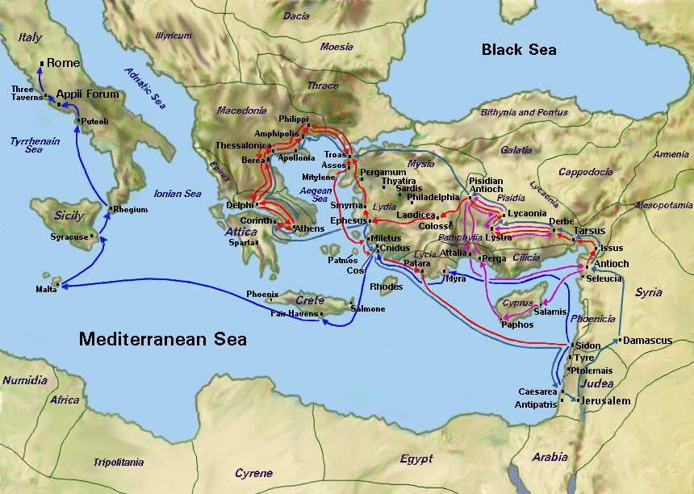
Philippi

Rome

Jeremiah Lumpier's example
Six men came to pray many years ago and, as a result of an invitation given by Jeremiah Lumpier who was a merchant. His church was not doing well. Jeremiah used to pray in his own church after he had visited people and encouraged them to attend church. Suddenly an idea came to him. May be people will be willing to come to pray a short time at noon! And he put up a placard. The meeting had to start at 12 noon and nobody came until 12:30! Suddenly one man came, then another until there were six. They prayed a short time and decided to pray again next Wednesday. Lumpier did not know that this was the beginning of a revival that will led to Christ one million people!
SCHEDULE FOR THIS WEEK
Wednesday 6 pm - Prayer Service.
7 pm - Worship Service and the study of the Book of James.
8 pm - Fellowship on every Wednesday.
Thursday 7 pm - Street Fair University in Downtown, Palm Springs.
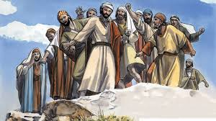
Saturday 11 am - Prayer for the sick, the church and revival in Coachella Valley.
Sunday 9 am-Prayers Service to 9:45.
10 am-Worship Service
10:30 am-Children Ministry from 10:30 am until 11:10 am.
10:30 am-Youth Ministry until 11:15.

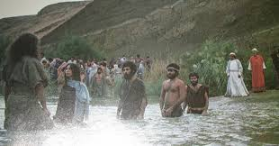
Are you ready to be baptized?

If you are born again, you are
Ready to be baptized!
Fill up the connection card
Today!
SERVANTHOOD-Let us know if you would like to help in the church with the cleaning, ushering, prayer for the Sunday service or Wednesday.
Our Mission is to EQUIP the people with God’s Word and PRAY for the Holy Spirit’s RIVERS of living water to empower the disciples, being fruitful in every good work as fishers of men.
Therefore, we pray, evangelize, disciple, teach and finally equip the leaders!
Core Verses: “If anyone thirsts, let him come to Me and drink. He who believes in Me, as the Scripture has said, out of his heart will flow rivers of living water.’ John 7 :37.
“Go and make disciples of all nations, baptizing them ..and teaching them..” Matthew 28:20. “Christ we preach warning every man and teaching every man in all wisdom, that we may present every man perfect in Christ Jesus. Col. 1:27
Street Fair University:
If you would like to be a part of the evangelistic team on Thursday evening (7PM), please let us know. Please, fill out the connection card.

Tel 760-898-5848. Info@livingwaterps.org. Send us an email. Thanks

