**June 28, 2015**

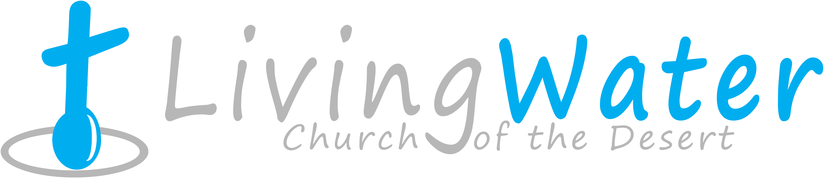

p r a y . e v a n g e l i z e . d i s c i p l e.

The Power of Christ

Bible Text

Luke 4:1-14

Key Verse

Luke4:14

Keyword ***power*** - dynamic strength

1. The 1st temptation of Jesus.

2. The 2nd temptation of Jesus.

3. The 3rd temptation of Jesus.

**Come and Worship with us on Wednesday**

On July 1, 2015

Prayer at 6pm, at 7pm Worship/Bible study & Youth Group.

**Rev. 9:20,"** But the rest of mankind, who were not killed by these plagues, did not repent of the works of their hands, that they should not worship demons, and idols of gold, silver, brass, stone, and wood, which can neither see nor hear nor walk. 21 And they did not repent of their murders or their sorceries or their sexual immorality or their thefts. "

You are invited to grow as a disciple every Sunday from 9 AM to 9:45 PM. Refreshments will be served. Fill the connection card if you would like to attend.

**Invite a friend to church**

**Thursday**- Come and join us for Downtown Evangelism at 7pm

at the Sonny Bono Statue.

**Friday** - Fasting day for our church (morning to noon or sundown).

**Saturday** - Prayer meeting at 11am. Church Cleaning at 12pm.

**Sunday** - Prayer at 9am, Worship Service at 10am.

**Discipleship**: **The Grace and the Law**

**The Grace** is based on faith / justifies sinful men /begins and ends with Christ / is the way of the Spirit / is a "blessing"/ is Gods desired end for His people / results in intimacy with Christ

**The Law-** is based on works / is incapable of in justifying you / makes Christ nothing / is the way of the flesh / is a "curse" / was given to expose sin / results in separation from Christ.

**Water Baptism** (Gk. *baptizo*) This Greek word means "to dip" or "to immerse." The people were coming to John and being immersed by him in the Jordan River. The Jews were familiar with the baptism of Gentile proselytes to Judaism; but this kind of baptism for Jews was new and strange to them. John called upon them to be baptized as a way of showing that they wanted to renounce their old way of life and prepare their hearts for the coming of the Messiah. Paul used baptism to speak about the believers' identification with Christ. Just as a cloth dipped in dye absorbs the color of the dye, so a person immersed in Christ should take on the nature of Christ.

**Bible Promises** Gal. 4:24-27 "For these are the two covenants: the one from Mount Sinai which gives birth to bondage, which is Hagar- 25 for this Hagar is Mount Sinai in Arabia, and corresponds to Jerusalem which now is, and is in bondage with her children- 26 but the Jerusalem above is free, which is the mother of us all. 27 For it is written: *"Rejoice, O barren, You who do not bear! Break forth and shout, You who are not in labor! For the desolate has many more children, Than she who has a husband."*

If you have any questions feel free to contact Pastor George or Lucia.

5000 Calle San Raphael #c5

Palm Springs, CA 92264

(760) 898-5848

Find us on Facebook

**Invite a friend to church**