**Sunday**

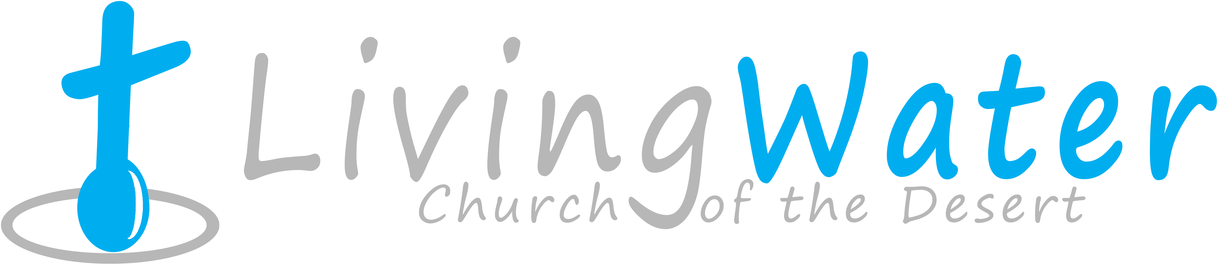

**Aug. 9, 2015**

p r a y . e v a n g e l i z e . d i s c i p l e.

The Bridegroom's Friends

**Bible Text**

Matthew 2:13-28

**Key Verse**

Matthew 2:21

**Key Word**  Friend - ally

1. Jesus, the friend of the sinners.

2. Jesus, the friend of the disciple.

3. Jesus, the friend of the freedom.

**Wednesday-** Prayer starts at 6pm. Bible study starts at 7pm.

**Thursday**- Come and join us for Downtown Evangelism at 7 pm at the Sonny Bono Statue.

**Friday** - Fasting day for our church (morning to noon or sundown).

**Saturday** - Prayer meeting at 11am, Church Cleaning at 12 pm.

**Sunday** - Prayer at 9am, Worship Service at 10 am.

**Pray for**:

A. Revival in the Coachella Valley

B. Downtown Evangelism Ministry on Thursday at 7 PM.

C. The lost to accept Jesus in the month of August.

D. Prayer Ministry on SUN at 9 AM, WED at 6 PM.

**Discipleship:** "They (the disciples) left their nets and followed Him"-Mark 1:18. The disciples took a decision that changed their live forever. The words of Jesus disconnect us from sin, bad habits and even addiction and set your life on a new course. Fill out the connection card if you would like to enroll in the discipleship class today.

**Bible Promises****: 1 Peter 1:22-24,"***Seeing ye have purified your souls in obeying the truth through the Spirit unto unfeigned love of the brethren, see that ye love one another with a pure heart fervently:*  ***23*** *Being born again, not of corruptible seed, but of incorruptible, by the word of God, which lives and abides forever.* ***24*** *For all flesh is as grass, and all the glory of man as the flower of grass. The grass withers, and the flower thereof falls away*."

**Invite a friend to church**

**Summary: The Book of Revelation # 1-15.**

Revelation #1- The Living Christ

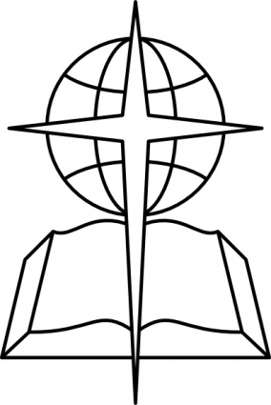

Revelation #2- The Seven Churches A

Revelation #3- The Seven Churches B

Revelation #4- The Divine Worship

Revelation #5- The Sealed Scroll

Revelation #6- The Seven Seals.

Revelation #7- The Faithful Martyrs

Revelation #8- The Seven Trumpets-A

Revelation #9- The Seven Trumpets-B

Revelation #10-The Little Book

Revelation #11-The Two Witnesses

Revelation #12-The victory of Israel

Revelation #13-The Pricey Worship

Revelation #14 -The Eternal Gospel

Revelation #15-The Song of the Lamb.

**DID YOU KNOW?** Manfred, Freiherr von Richthofen was a famous German First World War fighter pilot. He was better known as the Red Baron because he flew a distinctive a red Fokker aircraft. He shot down more combat planes than anyone else on either side in the First World War. His known kill tally was 80.

On 21st April 1918, he began chasing a Canadian plane - that was trying to escape the battle over the Morlan court Ridge, near the river Somme. As the Red Baron pursued his prey, he strayed behind Allied lines. He dived too low into the enemy lines. And he also he missed a Canadian pilot (Arthur) "Roy" Brown coming up on his tail to help his comrade. We will never know whether it was a shot from the ground - or a shot from Brown that killed Richthofen. But *what we do know is that the "Red Baron" came to his end because he made the mistake of pursuing that Allied 'plane "too long, too far, and too low into enemy territory" (as one report so succinctly put it) . And many committed Christians have been shot down because they have* followed temptation for too long, too far, and too low into enemy territory. And as with Richthofen -- they are then caught unawares and then have to deal with the consequences.

**Water Baptism:** Did you know?

**a.** Paul was baptized after 3 days.

**b.** Jesus was baptized-Luke 3:21.

**c.** It is a symbol of Jesus' death and resurrection-Rom. 6:4-6.

**d**. The Philippi jailor was baptized at 2 AM in the morning.

**e**. In the Day of Pentecost 3,000 believers were baptized.

If you have any questions feel free to contact Pastor George or Lucia.

5000 Calle San Raphael #c5

Palm Springs, CA 92264

(760) 898-5848Find us on Facebook

**Invite a friend to church**