**Sunday**

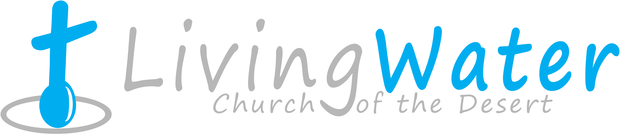

**Sept. 6, 2015**

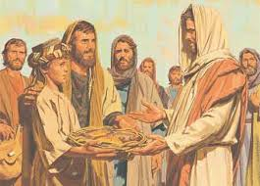p r a y . e v a n g e l i z e . d i s c i p l e.

The Feeding of 5,000

**Bible Text**

Mark 6:1-56

**Key Verse**

Mark 6:41

**Key Word**  Twelve - God's regime.

1. The ministry in Jesus’ Town ........# 6: 1-6

2. The ministry of 12 Disciples……# 6: 7-13

3. The ministry of John Baptist..... # 6:14-23

4. The ministry of multiplication ... # 6:24-32

5. The ministry of healing-touch …..# 6:33-5

**Wednesday** - Prayer at 6pm, Worship/Bible study & Youth Group at 7pm.

The Book of Revelation chapter 19 - *The Political Babylon.*

**Thursday**- Come and join us for Downtown Evangelism at 7 pm at the

Sonny Bono Statue.

**Friday** - Fasting day for our church (morning to noon or sundown).

**Saturday** - Prayer meeting at 11am, Church Cleaning at 12 pm.

**Sunday** - Prayer at 9am, Worship Service at 10 am.

**Invite a friend to church**

**The 12 Disciples:** In Mark # 6 Jesus is sending the 12 disciples to preach the gospel. This is a major shift in the ministry of the 12 disciples. A remarkable changed took place in their life already. They have been with Jesus! Did you see the metamorphosis from caterpillar, the cocoon and to butterfly? Jesus is an expert of taking us from caterpillar stage to the butterfly phase. Too many believers remain in the caterpillar mode. Jesus is calling us to higher ground. Let's fly spiritually closer and closer to the place of power and authority in God's kingdom. Let's follow the example of the 12 disciples who got power over very disease, anointed the sick with oil and healed them-Mk. 6:13.

**Discipleship:** As disciples of Christ we need to learn to release control of our life in the hands of Almighty God. Sometimes we are at the end of the rope and still we want to be in control. God wants us to be disciples but we may want to focus on our daily business of life never having time to sit at the feet of Jesus. Suddenly life is not easy anymore because sin is capturing your sight. It’s like climbing on a bridge and the heights are making us uncomfortable. In 1932 when a bridge was built, one man was lost for every one million dollar spent! For a bridge that cost 40 million, 40 people lost their life. As a result, as the Golden Gate Bridge was built in 1932, a safety net was set below the bridge. Nineteen people felt from the bridge and none of them died! What is the lesson? Put your life in the hands of Almighty God and be a disciple. Even if you deny Him like Peter His hands are the safety net that will catch you. Keep your eyes on Him!

**Water Baptism:** Let us know in advance if you would like to be baptized. Remember, Jesus was baptized although He never sinned. It is an act of righteousness.

Matthew 28:19-20 **19**Go therefore and make disciples of all the nations, baptizing them in the name of the Father and of the Son and of the Holy Spirit, **20**teaching them to observe all things that I have commanded you; and lo, I am with you always, *even* to the end of the age. Amen.

If you would like to know more about being baptized please, write your name and phone number on the connection card.

**Downtown Evangelism:** If you would like to be a part of the evangelistic team on Thursday evening (7PM), please let us know. Please, fill out the connection card.

If you have any questions feel free to contact Pastor George or Lucia.

5000 Calle San Raphael #c5

Palm Springs, CA 92264

(760) 898-5848

Find us on Facebook

**Invite a friend to church**