**Sept. 27, 2015**



**Sunday**

p r a y . e v a n g e l i z e . d i s c i p l e.

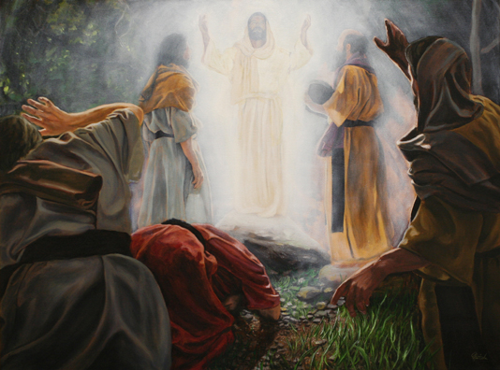

The Transfiguration

**Bible Text**

Mark 9

**Key Verse**

Mark 9:2

**Key Word**

*Transfiguration* -metamorphosis

1. Jesus Christ' glory on the mount.

2. Jesus Christ' glory in the valley.

3. Jesus Christ' glory at the cross.

4. Jesus Christ' glory in His words.

**Wednesday** - Prayer at 6pm, Worship/Bible study & Youth Group at 7pm.

**The Book of Revelation chapter 22**

*“The Paradise of God”*

**Thursday**- Come and join us for Downtown Evangelism at 7 pm at the

Sonny Bono Statue.

**Friday** - Fasting day for our church (morning to noon or sundown).

**Saturday** - Prayer meeting at 11am, Church Cleaning at 12 pm.

**Sunday** - Prayer at 9am, Worship Service at 10 am.

**Galatians 5:16** *This* I say then, Walk in the Spirit, and ye shall not fulfil the lust of the flesh.

**Discipleship:** Matt. 9:9-10 And Jesus said to him, "Follow Me." So he arose and followed Him. **10** Now it happened, as Jesus sat at the table in the house, *that* behold, many tax collectors and sinners came and sat down with Him and His disciples." A great lesson from Jesus. He had time and patience to eat with the tax collectors and sinners. Jesus loved to fellowship and eat with the poor and the rich who did not know Him. Let's do the same

1. The disciple “***denies”*** himself.

2. The disciple “***carries”*** the cross.

3. The disciple “***follows*** “Christ.

4. The disciple **"*loses*"** his life.

5. The disciple "***saves***" his soul.

6. The disciple “***loves****”* Jesus' words.

7. The disciple “***looks****”* for His coming.

8. The disciples “***sees****”* the Son of Man.

**Bible Promises:** Philippians 4:15-18 **"** Now ye Philippians know also, that in the beginning of the gospel, when I departed from Macedonia, no church communicated with me as concerning giving and receiving, but ye only. **16** For even in Thessalonica ye sent once and again unto my necessity. **17** Not because I desire a gift: but I desire fruit that may abound to your account.  **18** But I have all, and abound: I am full, having received of Epaphroditus the things *which were sent* from you, an odor of a sweet smell, a sacrifice acceptable well pleasing to God."

**Food for the Poor:** We collect food for the poor.You can bring food on Sunday morning at 10 AM or Wednesday evening at 7 PM. Isaiah 58:10, If you extend your soul to the hungry, And satisfy the afflicted soul, Then your light shall dawn in the darkness, And your darkness shall *be* as the noonday.11 The Lord will guide you continually, And satisfy your soul in drought, And strengthen your bones.

**Downtown Evangelism:** If you would like to be a part of the evangelistic team on Thursday evening (7PM), please let us know. Please, fill out the connection card.

**The Book of Revelation Ch. 22** *“The River of Life”*

Revelation #1- The Resurrected Christ

Revelation #2- The Seven Churches-A

Revelation #3 - The Seven Churches-B

Revelation #4 - The Divine Worship

Revelation #5 - The Sealed Scroll

Revelation #6 - The Seven Seals.

Revelation #7 - The Faithful Martyrs

Revelation #8 - The Seven Trumpets-A

Revelation #9 - The Seven Trumpets-B

Revelation #10-The Little Book

Revelation #11-The Two Witnesses

Revelation #12-The Victory of Israel

Revelation #13-The Pricey Worship

Revelation #14-The Eternal Gospel

Revelation #15-The Song of the Lamb

Revelation #16-The Seven Bowls

Revelation # 17-The Religious Babylon

Revelation # 18-The Financial Babylon

Revelation # 19-The Supper of the Lamb

Revelation # 20-The Millennium Kingdom

Revelation # 21-The New Heaven & Earth

Revelation # 22- The Paradise of God

__________________________________________________________________________________________

If you have any questions feel free to contact Pastor George or Lucia.

5000 Calle San Raphael #c5 (760) 898-5848

Palm Springs, CA 92264 Find us on Facebook

**Invite a friend to church**