****p r a y . e v a n g e l i z e . d i s c i p le

Jan 29, 2017

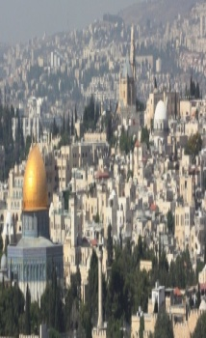 Message: ”The God that Became Man**”**

Bible Text: John 8:23-51

“Christ we *preach*, warning every man and*teaching* **every man in all wisdom to present every man *perfect* in Christ.**

**Outline**

1. Jesus prophesied His quick departure.

2. Jesus proclaimed His plan for freedom

3. Jesus pronounced what is Satan’s plan.

4. Jesus proclaimed Himself as the I AM.

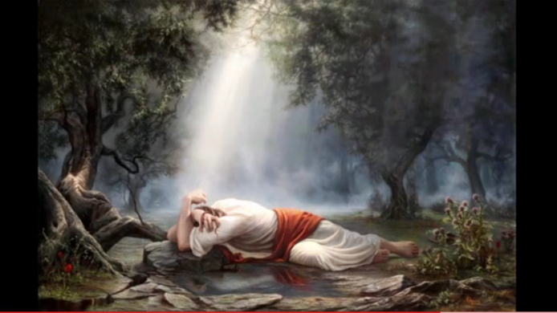[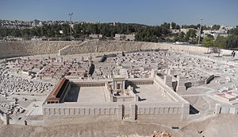](https://en.wikipedia.org/wiki/File:Jerusalem_Modell_BW_2.JPG)

Wednesday at 7 PM we study the Book of Romans

Receive the certificate for the Book of Romans!

The Book of Romans led to the reformation on Oct. 1517 and the church was never the same. Millions of people were changed and transformed by the Lord and the Bible that became available to all people, the rich and the poor, the king and the slave. Please, pray diligently for a great revival in our church.

Discipleship: 12 As many as desire to make a good showing in the flesh, these *would* compel you to be circumcised, only that they may not suffer persecution for the cross of Christ. ..14 But God forbid that I should boast except in the cross of our Lord Jesus Christ, by whom the world has been crucified to me, and I to the world. 15 What do we boast? Paul boasted in the Cross of Jesus Christ. Let's do the same as disciples of the Lord.”

Multiply Yourself in 2017 !

Peter led 3,000 souls to Jesus in 1 DAY!

1. The Great Commission is for all believers.

2. There is a great reward for doing God’s will.

3. The *Great Omission* means to reject the lost

4. The prayer for the lost is always heard by God.

5. Barnabas was a great soul winner-Acts 11:24

6. Jesus on the cross led a thief to salvation.

7. Let the Lord of the harvest lead you to the lost.

**Baptism.** Are you ready to be baptized? Fill out the connection card.

‘Go and make disciples baptizing them and teaching them..” Mat:28:19.

SCHEDULE FOR THIS WEEK

Wednesday *6 pm-* Prayer Service.

2017 *7 pm****-* Worship Service** and study of the Book of Romans

*8 pm-* Fellowship on every Wednesday.

Thursday *7 pm-* Street Fair University in Downtown in front

of the Sonny Bono Statue.

Saturday 11 Am Prayer for the sick, the church and revival.

Sunday *10 am*- Prayer Service.

*11am*-Worship Service.

*11am*- **Children Ministry** from 11am until 12:10 am.

Fellowship after every service.

*11:30am*-Youth Ministry until 12:15.

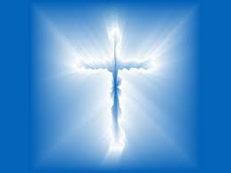

**Living Water Church**

5000 Calle San Raphael #c5 info@livingwaterps.org

Palm Springs, CA 92264 (760) 898-5848