****p r a y . e v a n g e l i z e . d i s c i p le

Feb 5, 2017

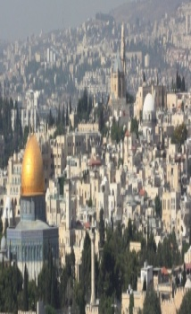 Message: ”The Healing of the Daughter of Canaan”

Matthew 15:21-31

“Christ we *preach*, warning every man and*teaching* **every man in all wisdom to present every man *perfect* in Christ.**

[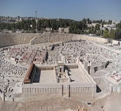](https://en.wikipedia.org/wiki/File:Jerusalem_Modell_BW_2.JPG)

**Healing Sunday**

Jesus heard the shout of the woman of Canaan

Jesus tested the hope of the woman of Canaan.

Jesus spoke the word to the woman of Canaan

Jesus healed the child of the woman of Canaan.

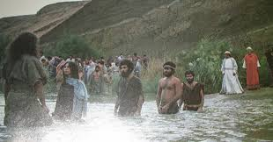

Wednesday at 7 PM we study the Book of Romans

Great surprise for all who attend the WED, Feb.8th Service

The Book of Romans led to the reformation on Oct. 1517 and the church was never the same. Let’s pray diligently for a *revival in our church*. Every revival is the result of prayer and repentance according to Jesus’s great teaching in the Bible!

Discipleship: 12 As many as desire to make a good showing in the flesh, these *would* compel you to be circumcised, only that they may not suffer persecution for the cross of Christ. ..14 But God forbid that I should boast except in the cross of our Lord Jesus Christ, by whom the world has been crucified to me, and I to the world. 15 What do we boast? Paul boasted in the Cross of Jesus Christ. Let's do the same as disciples of the Lord.”

Multiply Yourself in 2017 ! Invite your family, friend,

coworkers, mother , father to hear the gospel of Christ!

“Those who lead many to righteousness shall shine like the STARS!”

***Worship*** *is* the most urgent, the most glorious action that can take place in the human life. Karl Barth;

Wash your face every moment in *worship*. Spurgeon

We **always become what we worship**!

**Baptism.** Are you ready to be baptized? Fill out the connection card.

‘Go and make disciples baptizing them and teaching them..” Mat:28:19.

SCHEDULE FOR THIS WEEK

Wednesday *6 pm-* Prayer Service.

2017 *7 pm****-* Worship Service** and study of the Book of Romans

*8 pm-* Fellowship on every Wednesday.

Thursday *7 pm-* Street Fair University in Downtown in front

of the Sonny Bono Statue.

Saturday 11 Am Prayer for the sick, the church and revival.

Sunday *10 am*- Prayer Service.

*11am*-Worship Service.

*11am*- **Children Ministry** from 11am until 12:10 am.

Fellowship after every service.

*11:30am*-Youth Ministry until 12:15.

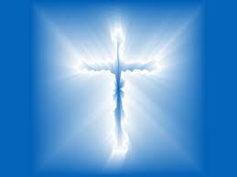

**Living Water Church**

5000 Calle San Raphael #c5 info@livingwaterps.org

Palm Springs, CA 92264 (760) 898-5848